Job description
Job title: | Cashier
Department: | Visitor Experience | Contract: | Part Time, permanent
Reporting To: | Head of Visitor Experience | Hours per week: | 18 hours

1. Job purpose
To process the cash received by the Trust from both till sales and donations.
To provide admin support to the finance department.

2. Dimensions
Bank up to £30k of cash from 14 different tills across three sites on a weekly basis
Bank £1.5k-£2k of donations and slot machine income
Perform weekly safe and till checks and order float and change accordingly

3. Principal accountabilities
- Count, check and bank cash received by Trust till sales to ensure accurate recording of admissions income
- Investigate all discrepancies and ensure they are recorded and reported to enable them to be investigated
- Undertake random spot checks on the tills and safes at all sites weekly to prevent fraud
- Organise and receive change orders to ensure that each site has adequate change for daily operations.
- Collect, record and bank donations and slot machine income monthly in order to accurately record our other income
- Make up till and safe floats when required for use by the tills each day
Other duties
- Undertake such duties of a similar nature which fall within the job purpose and are consistence with the grading of the post
- Actively engage in and contribute to own professional development

4. Key performance measures
- Cash is banked weekly at all three sites
- Slot machines and donation boxes are banked monthly

5. Knowledge, skills, experience and behaviours

Knowledge
- Good working knowledge of Microsoft Office, in particular Excel
- Knowledge of Finance and EPOS systems
- Knowledge of cash handling processes

Skills
- Excellent Communication
- Excellent Customer Care
- Excellent organisational skills and attention to detail
- Ability to use initiative and effectively problem solve
- Ability to prioritise in a fast moving environment
- Excellent numerical and record keeping skills
- YMT has a strategic commitment to increasing its digital skill base. The post holder should be able to demonstrate competence in one or more of the following areas:
  - Digital recording – e.g. photography, sound, video
  - Social networking – e.g. twitter, Facebook

Experience
- Working with Finance and EPOS systems
- Extensive experience in cash handling

Behaviours
- Commitment to equality and diversity and an understanding of how this commitment applies to this role.
- Willingness to be a team player
- Willingness to lean about and use new technology
- Flexible attitude towards performing tasks and providing cover for colleagues
- Discretion in working with confidential information

6. Key relationships
Finance Team
Visitor Experience

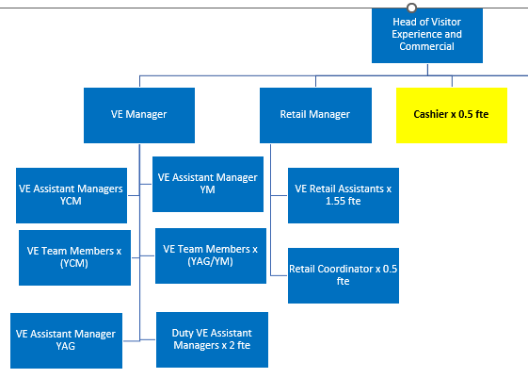
7. Organisation chart

