Job description
Job title: | Wedding & Events Host
Department: | York Venues | Contract: | Part Time, permanent.  Part Time, Fixed Term (up to and including 30th September 2022)
Reporting To: | Wedding & Events Manager | Hours per week: | 16  Mainly evenings and weekends

1. Job purpose

To work as part of the Venues Team assisting the hosting and delivery of weddings, conferences and other events for York Venues. Ensuring the successful operational delivery and consistently maintaining and managing excellent customer service at all times.

2. Dimensions

Hosting events across all of York Museums Trusts sites
Event capacities range from around 50 – 300 depending on the venue plus more in York Museum Gardens
Event timings are (guide only) 9am – 5pm for weddings, 5pm – 1am for evening weddings and events.
7am – 7pm for conferences

3. Principal accountabilities

- Set up the York Venues for events, including moving furniture and equipment, in accordance with function instructions.
- Provide outstanding customer service to all clients, guests and contactors/suppliers at all times across all sites by engaging, welcoming, informing and orientating clients during weddings and events.
- Keyhold and take responsibility for our main venue, the Hospitium,
- To quickly and calmly deal with unexpected issues and complaints on event days, often without a manager physically present
- Demonstrate understanding of and sensitivity to meeting the special needs of disabled clients and clients with diverse cultural backgrounds.
- Help to maintain a clean and orderly environment, working in conjunction with our catering and cleaning partners to ensure all our sites sustain a high level of cleanliness and organisation.
- Work in the office answering the phone, dealing with enquiries and bookings and general administrative duties when needed.
- Promote and develop equality and diversity in line with YMT Equality Statement.
Other duties
- Other duties may be required from time to time which are consistent with the grading of this post

4. Key performance measures

Feedback from Clients and colleagues
Positive feedback on social media, and direct to the department via phone, email and letter from the Clients

5. Knowledge, skills, experience and behaviours

Knowledge
- A thorough knowledge of emergency procedures, including First Aiders and evacuation procedures, to ensure events run safety and according to relevant legislation.

Skills
- Good communicator
- Organised
- Ability to manage time effectively
- YMT has a strategic commitment to increasing its digital skill base. The post holder should be able to demonstrate competence in one or more of the following areas:
  - Digital recording – e.g. photography, sound, video
  - Social networking – e.g. twitter, Facebook

Experience
- Experience within a customer facing role
- Some knowledge or experience of the wedding and events industry

Behaviours
- Friendly and approachable demeanour
- Appropriate and presentable appearance
- Flexible
- Commitment to and advocacy of equality, diversity, inclusion and anti-racism and understanding how these apply to the role.

6. Key relationships
Venues team
Clients
Contractors/Suppliers

7. Organisation chart
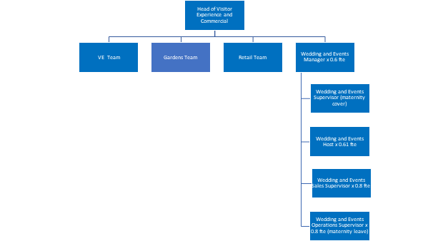

Terms and conditions of service

Job Title
Wedding & Events Host
Reporting line
This post reports to the Wedding and Events Manager

Salary
The salary for the post is £11,145.40 per annum (18,328.00 fte, YMT Grade 1)

Probationary period
Appointments are subject to the successful completion of a six-month probationary period.

Health
Prospective employees must be cleared by the Occupational Health Service as medically fit for employment by the Trust.

Annual leave
The annual leave entitlement is 25 days per annum (pro rata for part time roles), increasing by five days (pro rata) after five years continuous service with the Trust, plus public holidays.

Pension
The Trust belongs to the Local Government Pension Scheme and all new employees are enrolled. It is possible to opt out of the pension using forms available at www.nypf.org.uk.

Hours of work
The hours of work are 16 hours a week which will be predominantly evenings and weekends

Period of notice
The period of written notice required for you to terminate this post is one month. The Trust will give you one month’s notice.

