Job description
Job title: | Regional Accreditation Advisor
Department: | Museum Development Yorkshire | Contract: | Temporary until 31st March 2022 with potential extension to 2023
Reporting To: | Head of Museum Development Yorkshire | Hours per week: | 7.4

1. Job purpose

To develop excellence within museums in the Yorkshire and Humber region by providing technical Accreditation support and training opportunities to museums applying for and maintaining Museum Accreditation.

To provide professional development support to Accreditation Mentors.

2. Dimensions

Budget
Manage a workshop/training budget of c. £2500

Staff
Support the professional development of Accreditation Mentors; experienced heritage professionals who volunteer their time to help smaller museums achieve and retain Accreditation.

Impact
Responsible for:
- providing technical standards support and advice to 155 Accredited sites in maintaining Accreditation; the UK industry standard for museums and galleries.
- Conducting Eligibility Assessments for museums applying for Accreditation on behalf of Arts Council England.
- Liaising with Arts Council England Relationship Manager and Standards Team to identify museums at risk of significant change and to ensure that MDY is aware of current case-law.
- Organising training sessions focussing on separate areas of the Accreditation standard to be offered to c.150 museum professionals annually.

3. Principal accountabilities

- Co-ordination of Museum Accreditation support in the Yorkshire and Humber region.
- Provide mentoring and advice to assist museums to apply for and retain Museum Accreditation based on industry standards.
  - Support the development and rollout of the revised Accreditation Standard through the delivery of sub-regional briefings.
  - Provide regional Accreditation workshops or surgeries focussing on separate areas of the standard in a 'How to' format supplemented by Q&A surgeries.
  - Support every new or returning applicant through facilitation to complete a benchmark compliance check with an agreed action plan.
- Support the professional development of Accreditation Mentors.
  - Provide Accreditation Mentors with access to a discussion forum.
  - Deliver x 1 CPD event per annum for current and prospective Accreditation Mentors focussing on known areas of weakness (including Areas for Development and Required Actions) identified by Arts Council England and Museum Development Yorkshire .
  - Provide mentoring support to new Accreditation Mentors
- Conduct Eligibility Assessments for ‘Working Towards’ status on behalf of Arts Council England with the support of Museum Development Officers.
- Share intelligence with Relationship Manager and Standards Team to identify museums at risk of significant change and to ensure that MDY is aware of current case-law
- Collaborate with other Museum Development Providers to increase national consistency of service.
- Promote and develop equality and diversity in line with YMT Equality Statement.
Other duties
- Other duties may be required from time to time which are consistent with the grading of this post.

4. Key performance measures

100% of Accredited museums in the Yorkshire and Humber region that are developing an Accreditation Return are offered Accreditation support.
75% client engagement rate (uptake of Accreditation support offered).
2 x Accreditation workshops delivered annually.
1 x Accreditation Mentor workshop delivered annually.
100% of eligibility assessments conducted and submitted within authorised timescales (6 weeks).
80% client learning and development expectations ‘mostly or completely met’

5. Knowledge, skills, experience and behaviours

Knowledge
- Evidence of experience based competency in a museum and gallery setting equivalent to a level 7 qualification (e.g. master’s degree).
- Understanding of national museum, 3rd sector and public sector issues.
- Awareness of Museum Accreditation and SPECTRUM.

Skills
- Highly effective communicator both oral and written.
- Ability to manage and prioritise high volume and short timescale workloads.
- Understanding of approaches to relationship management both with individuals and organisations with demonstrable tact, diplomacy and empathy.

- YMT has a strategic commitment to increasing its digital skill base. The post holder should be able to demonstrate competence in one or more of the following areas:
  - Digital recording – e.g. photography, sound, video
  - Social networking – e.g. twitter, Facebook

Experience
- Experience of working at an operational level in museums or heritage management in two or more of the following:
  - Organisational health
    - Governance and management
    - Forward planning
    - Risk management
  - Managing collections
    - Collections ownership and development
    - Collections documentation
    - Collections care and conservation
  - Users and their experience
    - Public accessibility
    - Audience knowledge and development
    - User engagement and experience
- Experience of developing policies or procedures for Accreditation or SPECTRUM.

Behaviours
- Ability to work effectively within a small (dispersed) team of professional peers.
- Self-motivated to use ability, initiative and discretion to work autonomously and as part of a team.
- Flexible approach to work and working hours.
- Ability to meet regular regional and national travel requirements
- Commitment to and advocacy of equality, diversity, inclusion and anti-racism and understanding how these apply to the role.

6. Key relationships
Head of Museum Development Yorkshire
Museum Development Officers
Museum Development Yorkshire Project Intern
Other Museum Development Accreditation leads
Arts Council’s Standards Team
Arts Council’s Relationship Manager for Museums (Yorkshire)

7. Organisation chart
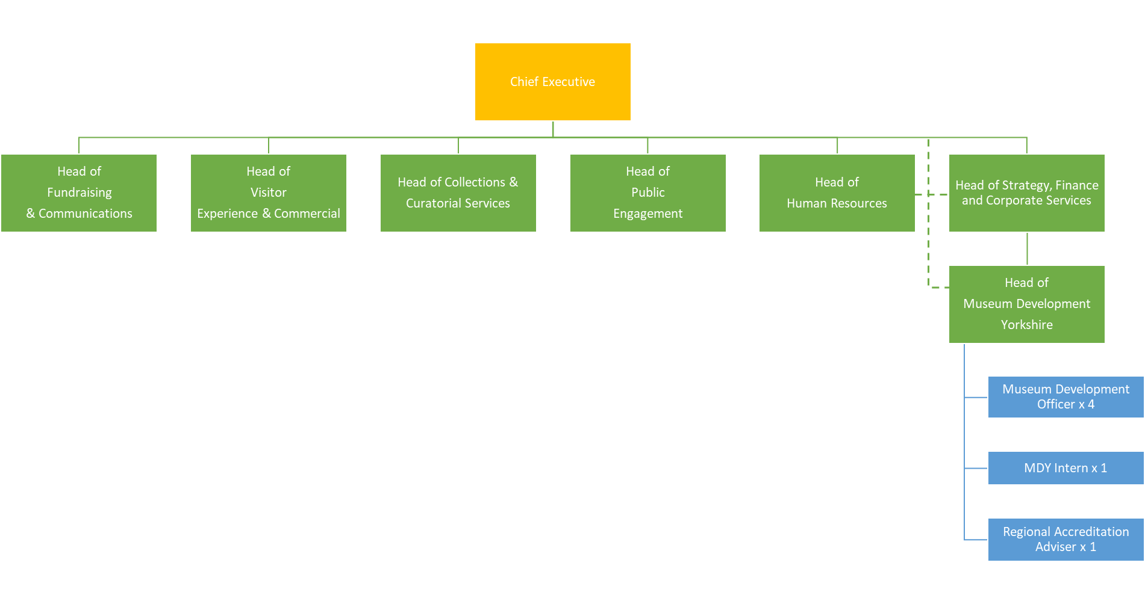

Terms and conditions of service

Job Title
Regional Accreditation Advisor

Reporting line
This post reports to the Head of Museum Development Yorkshire

Salary
The salary range for the post is £5,640.60 - 6,013.40 per annum (£28,203 – 30,067 full-time equivalent), YMT Scale SO1.

Probationary period
Appointments are subject to the successful completion of a six-month probationary period.

Health
Prospective employees must be cleared by the Occupational Health Service as medically fit for employment by the Trust.

Annual leave
The annual leave entitlement is 25 days per annum (pro rata for part time roles), increasing by five days (pro rata) after five years continuous service with the Trust, plus public holidays.

Pension
The Trust belongs to the Local Government Pension Scheme and all new employees are enrolled. It is possible to opt out of the pension using forms available at www.nypf.org.uk.

Hours of work
The hours of work are 7.4 hours per week, worked over one day.

Period of notice
The period of written notice required for you to terminate this post is one month. The Trust will give you one month notice.

