Candidate Brief

Trustee

York Museums Trust

February 2020

Contact: Olesya Pounder, Head of HR, e-mail: recruitment@ymt.org.uk, tel.: 01904 687621

Background

York Museums Trust, one of the most successful leading regional Museums and Gallery charities in the UK, is seeking to appoint a new Trustee to its Board. York Museums Trust (YMT) is an independent charitable trust, created in August 2002 by the City of York Council to manage York Art Gallery, York Castle Museum, Yorkshire Museum, Museum Gardens, York St Mary’s and associated collections. YMT now seeks a trustee with museum experience particularly in the areas of collections management and capital projects.

Our Mission

Proudly rooted in York and Yorkshire, we welcome everyone and look outwards, nationally and globally. We share collections, gardens, buildings, art and stories for learning, enjoyment and wellbeing. As a charity, our income enables us to care for York’s heritage and to benefit a wide range of people.

Our Headline Priorities are:

- Adopt a visitor first approach, with all decisions taken with the visitor’s needs in mind
- Progress two capital projects: the Castle Transformation Project and the Collections Storage and Development Project
- Excellent, high quality, audience-focussed programming, that drives visitors, raises our profile, meets our Creative Case and showcases YMT’s collections, sites and stories
- Increase our resilience by expanding enterprises and fundraising activities, investing in our people, and caring for our environment
- Improving York and York Museum Trust’s profiles through local, regional, national and international leadership and partnership to maximise YMT’s impact

Our charitable objectives are:
1) The advancement and support of scholarship, scientific enquiry, education and arts for the benefit of the citizens of York and of the public in Yorkshire and elsewhere, especially in the fields of antiquities, social history, painting, the decorative arts and the natural sciences; and/or
2) To provide opportunities for the citizens of York and visitors to the city to learn the history of the city and its region in terms of its people, culture and history together with its scientific, artistic and industrial development; and/or
3) The maintenance for these purposes and the benefit of the public of the Yorkshire Museum and Gardens, the Castle Museum, the York City Gallery, St Mary’s Church and any other premises together with the care, enhancement (by acquisition or other means), management and display of the collections within these institutions and display of collections from any other body which will promote the objects of the company; and/or
4) Such other charitable purposes beneficial to the community consistent with the objects above as the trustees shall in their absolute discretion determine.

York Museums Trust is responsible for:

York Art Gallery

Built in 1879 as the venue for the second Yorkshire Fine Art and Industrial Exhibition, the building was purchased by the local authority and re-opened as York Art Gallery in 1892. York Art Gallery has outstanding designated fine and decorative art collections comprising paintings that range from 14th century Western European paintings through to 20th century British work, an extensive collection of British Studio ceramics and over 15,000 works on paper. York Art Gallery re-opened in August 2015 following a £8m refurbishment programme with new galleries and the new CoCA Centre of Ceramic Art.
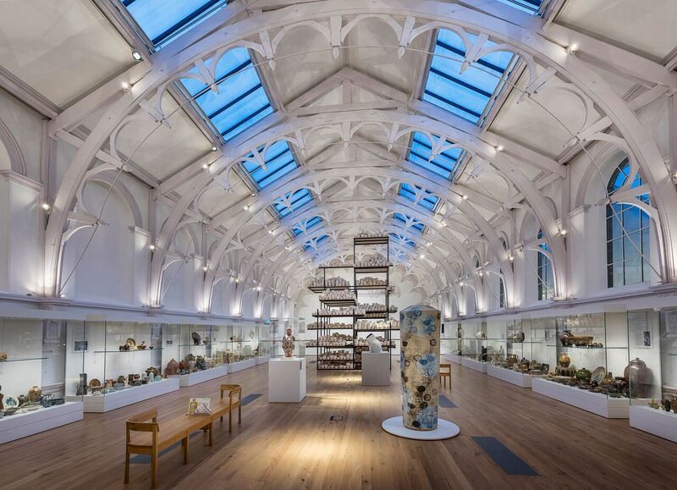

York Castle Museum

The York Castle Museum was founded by Dr Kirk in 1938 to house his extraordinary collection of social history which reflected everyday life in Yorkshire and the North of England. In two listed prison buildings, York Castle Museum’s most well-known display is Kirkgate Victorian Street, the first reconstructed street in any English museum. Working alongside City of York Council, York Museums Trust has ambitious plans to completely re-develop the Castle Area of the City with York Castle Museum as an anchor attraction within redeveloped public realm.

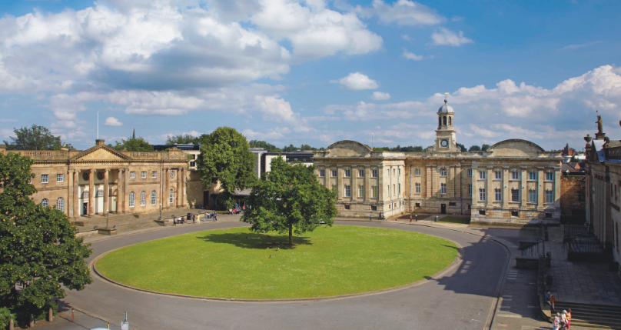

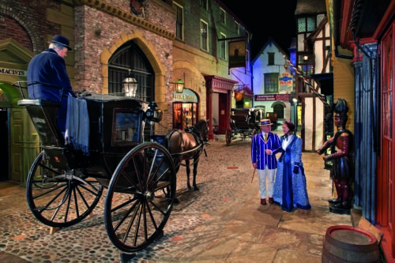

Yorkshire Museum

The Yorkshire Museum, set in Museum Gardens, was founded in the 1830s by the Yorkshire Philosophical Society The Yorkshire Museum houses the designated archaeological, geological and natural history collections. Recent new displays include VIKING: Rediscover the Legend which toured to three other venues in England and Yorkshire’s Jurassic World which uses technology to make the most of the museum’s important natural history collections.

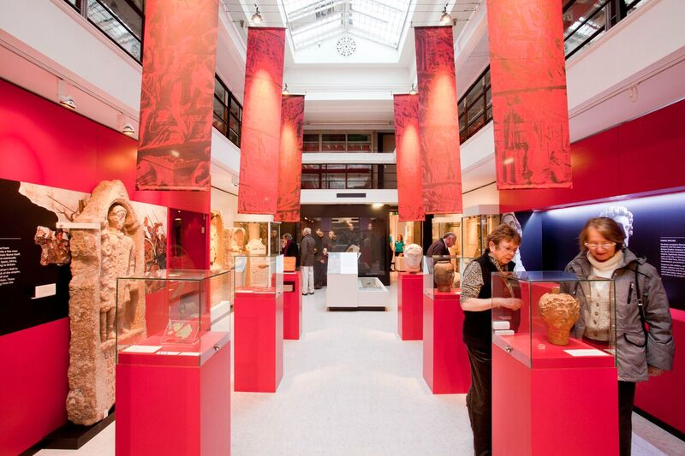

York Museum Gardens

York Museum Gardens is a Registered Historic Landscape and a Scheduled Ancient Monument including several listed buildings within its original 19th-century design. Within the Museum Gardens are the ruins of St Mary's Abbey and the 14th-century Hospitium, which provides an excellent venue for weddings, conferences and events and is an important source of revenue for York Museums Trust.

Collections

The Collections of York Museums Trust cover a broad spectrum of subject matter including: archaeology, biology, costume and textiles, decorative arts, fine art, geology, military history, numismatics, photography and social history. All the collections are Designated as of National importance, and these include the most representative and largest collection of British Studio Ceramics in the world. The Trust continues an active programme to grow the collections in its care.

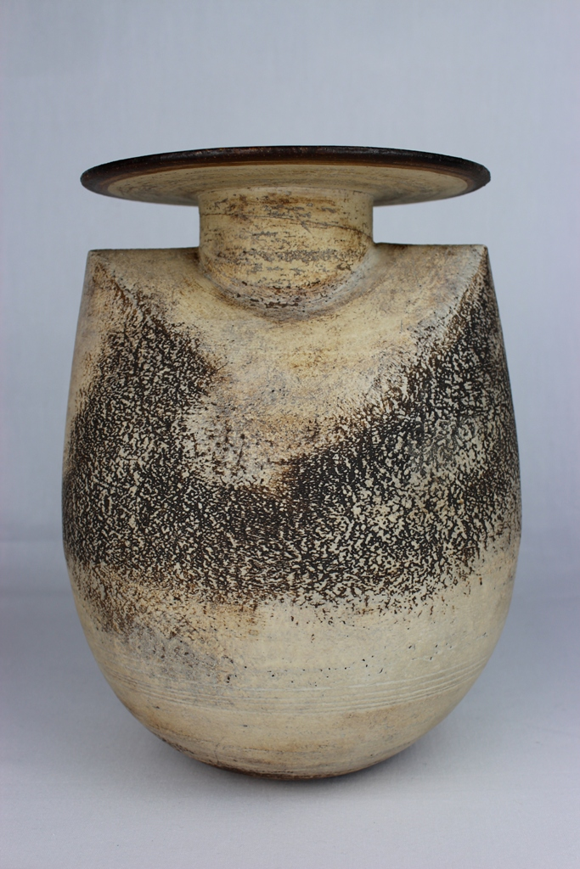

Organisation and Funding

York Museums Trust was formed on 1 August, 2002 as an independent charitable trust to manage the museums and gallery service previously run by City of York Council. The museums and galleries attract about 500,000 visitors each year with an additional c1.2m visits to the Museum Gardens.

YMT has a loyal and committed staff of ca 120 (FTE). The Chief Executive is Reyahn King who was appointed in 2015 and is responsible to the Board for the effective running of the organisation, supported by members of the Senior Leadership Team. There is also a very active Volunteers scheme with c 350 volunteers working with the organisation at any one time, providing invaluable support to the work of the Trust, its education and outreach programmes. The Trust is governed by the Board of Trustees (please see Appendix 1 for the list of Trustees).

York Museums Trust has an annual unrestricted income of ca £5.5m. Most of its income is generated by admissions. The Trust benefits from City of York Council revenue of £300k per annum supplemented by generous capital grants. YMT is an Arts Council England (ACE) National Portfolio Organisation and Arts Council funding provides around 20% of income. ACE recognise YMT as a UK leader in digital, promoting digital access to its collections and in recent years, supporting York’s ‘Mediale’ festival of Media Arts.

The Trust manages Museums Development Yorkshire, thorough a team funded separately by ACE, providing information, advice, guidance and consultancy to small and medium sized accredited museums across Yorkshire and Humberside.

The Trust also has a well-established trading subsidiary company, York Museums Enterprises which contributes more than £300k per year in profit from retail, venue hire, concessions, events and other commercial opportunities.

The Role of Trustee

The Board of York Museums Trust comprises up to 15 Trustees including the Chair. The Board has two members who are nominated by City of York Council and one member nominated by the Yorkshire Philosophical Society.

The Board meets six times per year. The Finance and General Purposes Committee also meets regularly with the Chief Executive and the Chief Operating Officer as a sub-committee of the Board. Other sub-committees of the Board are Audit, Remuneration and Nominations. There is an Annual Away Day to discuss the strategic direction of the Trust as well as ad hoc Task and Finish Groups, established as required.

Trustees have an important role to play as representatives and advocates of the Trust, enhancing its public profile and helping to ensure support and funding from both public and private sources. They have ultimate responsibility for directing the affairs of the Trust, for making sure it is solvent and sustainable, well run and delivering the charitable objectives for which it was established. They also contribute their expertise and experience in advising on policy and development of the organisation, assessing risk and supporting the Chief Executive and senior staff to whom operational management is delegated.

Specifically, the Board of Trustees:

- Approves the overall strategic direction of the Trust, setting policy, defining objectives, setting targets and evaluation performance;
- Ensures that the Articles of Association, charity and company law and other regulatory requirements are properly adhered to;
- Is active in supporting the work of the Trust’s various committees;
- Takes responsibility for the financial stability of the organisation and its future sustainability through careful attention to budgeting and resource issues, capital programmes and funding issues;
- Provides constructive support and challenge to the Executive team
- Oversees recruitment of the CEO

Description of Skills and Abilities

YMT currently has one vacancy for a new trustee with museums experience. The Trust is looking for candidates from a diverse range of backgrounds who can contribute to the Board at a time of ongoing change and ambition.

The Trustee can be at any stage in their career or personal development, but will need to have developed senior expertise and a track record of achievement in one or more of the following areas:

- Museums collections management
- Museums audience development
- Experience of project management in a significant, relevant organisation, especially capital projects

All trustees should be able to demonstrate:

- Understanding of charity governance arrangements
- A strong enthusiasm for York Museums Trust and its future ambitions
- A commitment to its Mission and Priorities
- Integrity and the ability to contribute effectively as a Board member.
- Be prepared to challenge the Trust’s Chief Executive in a constructive and collaborative way and with a focus on reaching good-quality, shared decisions
- Have the enthusiasm, ability and time to review papers and reports
- Understand and accept the legal duties and responsibilities of a trustee
- Good character and integrity.
- Communicate effectively, with good listening and speaking skills and be able to build and sustain good working relationships with fellow committee members and senior staff
- Use information technology confidently and be willing to communicate and share information electronically.

Terms of Office

The time commitment for the trustee is expected to be approximately seven days per year, all meetings will take place in York where possible attending previews and other events.

Appointments are made for a three-year period, renewable for a further three years.

The position of trustee is unremunerated, but reasonable expenses may be claimed.

Enquiries and How to Apply

To discuss this role and for further information, please contact Olesya Pounder – Head of HR:

Tel: 01904 687 621
Email: recruitment@ymt.org.uk

To register your interest in this opportunity, you are asked to submit:

- A copy of your CV;
- A copy of YMT Equal Opportunities form
- A statement of interest / letter indicating why you are interested and what you are able to bring to York Museums Trust’s Board

We would prefer to receive applications electronically. Please e-mail recruitment@ymt.org.uk, all applications will be acknowledged on receipt within 2 working days.
Alternatively post to: Olesya Pounder, Manor Cottage, Yorkshire Museum, Museum Gardens, York, YO1 7FR.
The closing date for the applications is 24 March 2020 at 09:00 am. Please note that York Museums Trust cannot be held responsible for non-delivery or late receipt of applications.
We expect to be able to inform the candidates whether they will be taken forward for an interview by the Nominations Committee by 05 April 2020.
Interviews will take place in York between 20 and 22 April 2020. Please indicate on your application whether you have any difficulties with this interview date.

Appendix 1: Trustees

James Grierson (Chair)
Sarah Drummond
Cllr Danny Myers
Cllr Simon Daubeney
Stephen Lusty (nominated by Yorkshire Philosophical Society)
David Andrews
Richard Jagger
Mary Haworth
Dr. Angela Dean
Philip Ashton
Prof. Dianne Willcocks CBE DL
Zulfi Hussain
Sita Brand

For more information on our trustees, see https://www.yorkmuseumstrust.org.uk/about-us/our-people/trustees/

