Job description
Job title: | Museum Development Yorkshire Intern
Department: | Museum Development Yorkshire | Contract: | Temporary part time (1 year)
Reporting To: | Head of Museum Development Yorkshire | Hours per week: | 22.2

1. Job purpose
To support the delivery of the Museum Development Yorkshire programme through the provision of administrative, logistical and communications assistance.

2. Dimensions
Summarise any numerical facts and figures that are relevant to the scale and degree of activity of the job such as budgets that they are accountable for or accountability for project spend or sales turnover etc. How many staff are they responsible for? How many direct reports? Which part of the organisation does the role have an impact on?

Responsible for providing administrative support towards the delivery of a National Portfolio Organisation contract for a government funded Arms Length Body (Arts Council England). Responsible for administrative and logistical support to MDY team, benefitting c.90 museum organisations representing 155 sites across the Yorkshire and the Humber region.

Monitor MDY Programme budgets circa £340,000 and raise purchase orders on behalf of MDY team.

3. Principal accountabilities
The 6-10 main areas of responsibility.

- Administrative support for the development and delivery of the regional programme

- Event management, co-ordination and hosting of training programme, including venue and speaker catering bookings; managing attendees; creation of copy for marketing, for the delivery of the regional programme

- Maintain an online presence including regular updating of website and twitter accounts so that museums and stakeholders are aware of the quality and range of the work of Museum Development Yorkshire

- Assist in development of high quality resources and support materials for Museum Development Yorkshire for the benefit of the museums across Yorkshire and the Humber

- Maintain procedural notes for all MDY activities to enable succession planning and operational continuity

- Develop knowledge and understanding of key museum management, education and collections skills and awareness of the regional museum community. This is so that the post-holder is equipped to support the work of Museum Development Yorkshire and is equipped to apply for work within the museum or cultural sector at the end of the internship.

- Ensure tasks are completed to deadlines, prioritising were necessary, to provide Museum Development Yorkshire with accurate, timely and efficient support

- Demonstrate discretion and a professional attitude when handling sensitive information to maintain corporate and professional standards

- Promote and develop equality and diversity in line with YMT Equality Statement.

Other duties
- Other duties may be required from time to time which are consistent with the grading of this post
- You may be required to travel regionally or nationally to ensure effective programme delivery
- You will be expected to occasionally work evenings or weekends to best support regional museums

4. Key performance measures
How will success in the job be measured? These should relate to the principal accountabilities.

Average 28 day twitter engagement rate to be over 1.5% (average/good engagement) to be checked quarterly
80% of feedback for Event Organisation rated good or excellent
100% of evaluations processed for training evaluation data reporting
Ensure delivery of 12x regional museum events per annum

5. Knowledge, skills, experience and behaviours
What is required for fully acceptable performance in the job?

Knowledge
- Knowledge of national or regional museum issues
- Understanding of social media and website Content Management Systems

Skills
- Communication - oral and written
- High attention to detail
- Good standard of numeracy and literacy
  - Level 2/GCSE 9-4 or A*-C or equivalent in English and Maths
  - Level 3/ AS Level or equivalent in any subject
- YMT has a strategic commitment to increasing its digital skill base. The post holder should be able to demonstrate competence in one or more of the following areas:
  - Digital recording – e.g. photography, sound, video
  - Social networking – e.g. twitter, Facebook

Experience
- Working or volunteering in museums or galleries (desirable but not required)
- Co-ordinating events and meetings
- Administration within a work environment

Behaviours
- Expectation and willingness to develop professionally, an ambition to work and demonstrable interest in the museum and cultural sector
- Commitment to equality and diversity and an understanding of how this commitment applies to this role.
- Self-motivated and a self-starter, able to work on own initiative
- Tactful and diplomatic
- Flexible approach to work and working hours, including evening and weekend hours.
- Ability and willingness to meet transport requirements, including regional and national travel
- Personally resilient, able to manage workloads and be responsive to a range of working styles
- Ability to complete tasks to deadlines.
- Demonstrate discretion and a professional attitude when handling sensitive information to maintain corporate and professional standards

6. Key relationships
What are the key internal and external relationships necessary for achievement of the job accountabilities?
Key Relationships
Museum Development Officers
Regional Accreditation Adviser
Project Consultants

Contact with
York Museum Trust’s Marketing and Communications team
Wider York Museum Trust teams
Regional museums

7. Organisation chart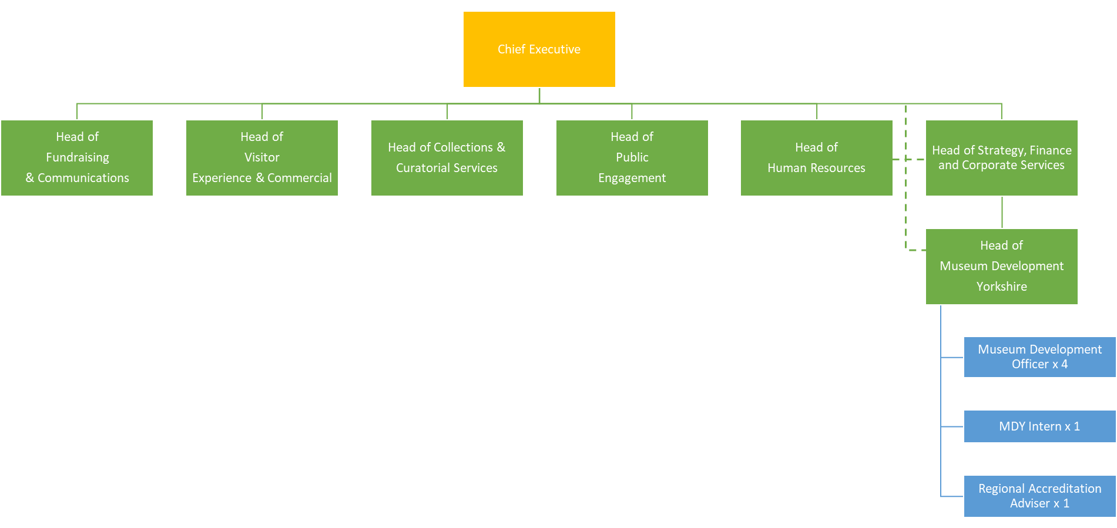

Terms and conditions of service
Job Title
Museum Development Yorkshire Intern

Reporting line
This post reports to Head of Museum Development Yorkshire
Salary
The salary for the post is SCP2, SCP 12 – 13, £17,364 - £17,673 per annum, pro rata (actual salary £10,418 - £10,603)

Probationary period
Appointments are subject to the successful completion of a six-month probationary period.

Health
Prospective employees must be cleared by the Occupational Health Service as medically fit for employment by the Trust.

Annual leave
The annual leave entitlement is 25 days per annum pro rata for part time employees, increasing by five days (pro rata) after five years continuous service with the Trust, plus public holidays.

Pension
The Trust belongs to the Local Government Pension Scheme and all new employees are enrolled. It is possible to opt out of the pension using forms available at www.nypf.org.uk.

Hours of work
The hours of work are 22.2 hours per week, worked over three days.

Period of notice
The period of written notice required for you to terminate this post is one month. The Trust will give you one month’s notice.

