Hello,

If you are reading this then you are considering applying for the intern position with Museum Development Yorkshire. You should; it’s a good job. Before we go much further I should probably introduce myself - I am Lily, the current intern, here to give you some tips and insight into the job before you apply.
The job itself consists of admin, event planning and logistics, and social media output. It’s an amazing job to have – I have learnt a lot of skills in the past 12 months and had a lot of fun with the team. But it’s not just that, I have got to attend events I wouldn’t have if I wasn’t at MDY, met people from a whole range of museum types across the region, visited sites I haven’t before, sat in on important decisions about funding and got to have some input with my opinion, and learnt so much. For me this job has the steepest learning curve of any job I have ever had and sometimes it felt quite terrifying but it is worth it.
The most important thing you need is the ability to take instructions and also work independently and find the balance between the two. There are some ongoing tasks that need to be completed as well as one off jobs requested by the Museum Development Officers.
Speaking of the Museum Development Officers, most have different working styles so you need to be comfortable working with a wide range of people. It’s good to be comfortable with a basic level of technology and be able to explain it well to other members of the team.
You will get a lot of opportunity to travel around the Yorkshire and Humber region to visit some wonderful museums for meetings, training and events. Travelling is a massive part of the role so you must be able to do it.
Honestly this is a fantastic job, the team are wonderful and are fully committed to helping you develop your career. Want it? Get on with your application.
Good luck with your application!
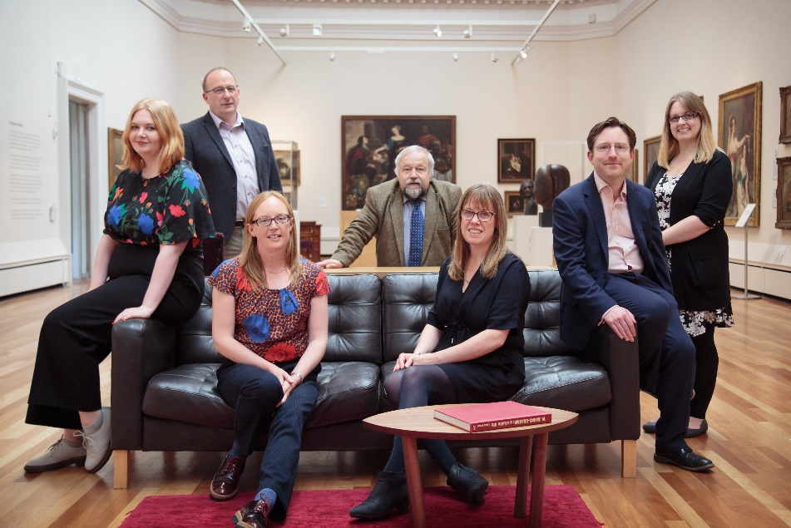
The MDY Team

