**York KS3 Prison Trail**

**Enter the prison exhibition from the Sixties Gallery. The area is dimly lit as it would have been in the 1700s, the era it represents.**

**There are spoken stories and projections in many of the cells.**

**All the stories are based on the lives of real people who lived or worked here.**

**On your right you can see and hear two children singing.**

Before Victorian times no distinction was made between criminals of any age so young children could be sent to an adult prison. There are records of children aged 12 being hanged.

The Victorians were very worried about crime and its causes and reformers were asking questions about how young people who had broken the law ought to be treated. They could see that locking children up with adult criminals was hardly likely to make them lead honest lives in the future, on the other hand, they believed firmly in stiff punishments. In 1854 Reformatory Schools were set up for offenders under 16 years old. These were very tough places, with stiff discipline enforced by frequent beatings. Young people were sent there for long sentences - usually several years. However, a young offender normally still began their sentence with a brief spell in an adult prison.

**j0078622.wmf**

**Do you feel that an adult prison is the right place for a young person who has broken the law? Why?**

_______________________________________________________________________________________________________________________________________________________________

Life in Georgian England was far harsher than it is today – so you can imagine that life behind bars was even worse.  
The Prison was divided into different floors, with the debtors above and the felons in the worst conditions below. They would sleep twelve or fifteen to a cell, “which causes very faint and nauseous smells and violent sicknesses”. The poorest of them would live on bread and water, sleep on bare boards, and wear nothing but rags in the unheated cells.

**Turn the corner and listen to the story of the turnkey, Thomas Ward.**

By 1815 taking fees from prisoners for board and lodging was forbidden and wages were paid to staff from the county rates (similar to today’s taxes).

**j0078622.wmf**

**Why do you think that this changed? What problems did they used to have?**  
_______________________________________________________________________________________________________________________________________________________________

_____________________________________________________

**Next, turn right and go to the cell on your right hand side. Here you can hear the story of Mary Burgan.**

**j0078622.wmf**

**Why do you think Mary chose to leave her son in prison with his father rather than taking him with her when she was released?**

_______________________________________________________________________________________________________________________________________________________________

**j0078622.wmfLeave this cell and walk forwards, past the Turnkey’s story and enter the cell on your left where you can hear the story of William Petyt.**

**What happened to the gaoler who beat William, causing his death?**

__________________________________________________________________________________________________________

**Do you think that was right? Why?**

_______________________________________________________________________________________________________________________________________________________________

Felons had no personal access to running water until after 1780. The pump was located just outside the fenced front courtyard and the gaoler’s servants brought water in by bucket.

**j0078622.wmf**A privy was built in about 1758. Before then, felons only had slop buckets to use for going to the toilet. Even after the privy was built, felons had to use buckets when confined to their sleeping cells, which could be as much as 14 or 16 hours a ‘night’. Come the morning, they emptied these into an open sewer that ran through part of the building.

**What problems do you think that an open sewer and lack of running water could have caused?** _______________________________________________________________________________________________________________________________________________________________

**Why was it so important to protect the health of prisoners?**

_______________________________________________________________________________________________________________________________________________________________

In about 1758, attempts were made to improve air circulation by the installation of ventilators in the ground floor building. Most sleeping cells had no outside air source and their only internal source was either a hole above the cell door, sized about 10cm x 20cm, or some 2cm perforations in the door. Many of these holes in the doors and above the doorways survive today.

The sleeping cells were supposed to hold three people per night, but numbers often exceeded that. One night in October 1737, nine men crammed into one of the cells died of suffocation.

**You can go into this cell (it is in darkness until you enter when a faint light is triggered)**

In 1746 the recorder of York complained to the archbishop that “when the turnkey opens the cells in the morning, the steam and stench is intolerable and scarce credible”.

But overcrowding may at least have helped to blunt the cold. There was no provision for fires in the sleeping cells, though the transports’ day room had a fireplace. Pre-1780 the floors were made of stone and bedding consisted at best of straw on low wooden pallets.

**Go into the cell opposite William Petyt’s. Here you can hear the story of Elizabeth Boardingham.**

Elizabeth was found guilty of petty treason, meaning that she committed an offence against a superior. In this case, the superior was her husband.

If a husband killed a wife, it was treated as murder.

**j0078622.wmf**

**Why do you think the two crimes were treated so differently?**

_______________________________________________________________________________________________________________________________________________________________

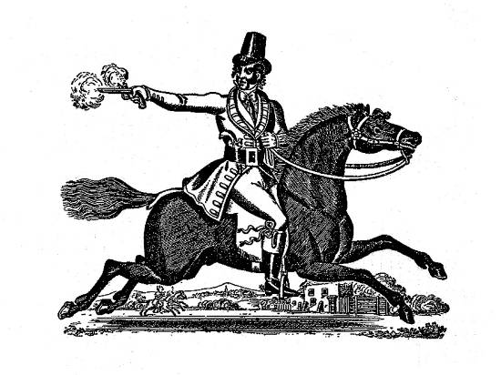**Leave Elizabeth’s cell by the far door and enter the cell opposite. This was the cell where Dick Turpin was taken from to be hanged.**

**Listen carefully to his story.**

**What was his profession before turning to a life of crime?**

* Butcher
* Baker
* Farmer

**What was he finally arrested for?**

* Robbery
* Selling stolen goods
* Horse – thieving

**What punishment was he expecting?**

* Hanging
* Transportation to America
* None – he expected to be released

Before his execution he paid for five mourners to follow the procession to the execution ground.

**j0078622.wmf**

**Why do you think he did this?**

_______________________________________________________________________________________________________________________________________________________________

After you leave the dark area of cells, there is information on the wall about the three ways you could get out of prison.

**What were the three ways?**

1. ________________________________________________
2. ________________________________________________
3. ________________________________________________

In the large cell on your right, you can hear four petitions from prisoners or groups of prisoners (*transcripts are available hanging on the wall as you enter*). A petition was the only way that prisoners had of trying to change things inside the prison.

**Name two things that prisoners wanted to change.**

__________________________________________________________________________________________________________

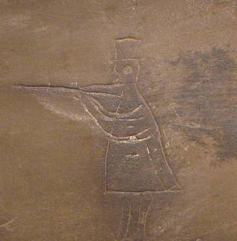

**Leave the petitions cell and turn right; here you can see two examples of graffiti done by prisoners hanging on the wall to your right.**

**What year did Joseph create his graffiti and how old was he?**

__________________________________________________________________________________________________________

**Enter the cell behind the wall with the graffiti. Here you can watch a short film about the history of justice at York Castle over the past 1000 years.**

**Find the image c1900 of prisoners on the treadmill at York.**

The original introduction of the treadmill had a useful purpose since the prisoners would be able to turn a wheel which could then be used to generate mechanical power which could be utilised profitably, such as by grinding corn or by turning machinery.

This very quickly stopped and prisoners were expected to put in their stints on the treadmill for long periods of time grinding nothing but fresh air!

Some prison administrators decided that the expense of installing a wheel was not justified and instead they installed a hand crank which the prisoner had to turn a certain number of times; dampening mechanisms could make it more difficult or easy to turn as required and prisoners were expected to turn a handle several thousand times per day in order to avoid punishment. Once again turning the handle achieved precisely nothing whatsoever.

To simplify matters even further some prisons require the inmates to carry out shot drill; this involved lifting heavy metal balls, carrying them to another location and then carrying them back again.

**Why do you think that prisoners were given tasks such as this to do?**

_______________________________________________________________________________________________________________________________________________________________

**Find evidence in this room of punishments used.**

_______________________________________________________________________________________________________________________________________________________________

_____________________________________________________

**j0078622.wmfLeave this cell by the far door and turn right. In front of you is a small cell where you can listen to poetry written by inmates here.**

**What are they writing about and why?**

_______________________________________________________________________________________________________________________________________________________________

_____________________________________________________

**Turn right where you will find information telling you what happened to the people whose stories you heard.**

**j0078622.wmfWilliam Hartley was hanged in 1813 for burglary. A similar crime today would receive a prison sentence of about 5 – 10 years.**

**Why did this happen?**

_______________________________________________________________________________________________________________________________________________________________

**In 1868 imprisonment for debt was abolished except in cases of fraud or refusal to pay.**

**j0078622.wmf**

**Why might this be ineffective?**

_______________________________________________________________________________________________________________________________________________________________

**Turn left into the final cell.**

**Here you can see a bed that was used in the prison along with a fireplace (the coals would have gone in the hole at the bottom and the smoke came out of the top.)**

**You can also put your name into our database and find out whether you had any relatives incarcerated here!**

**Prison reforms started in the 18th century and methods and punishments given are constantly changing.**

**j0078622.wmf**

**Is there anything that you still believe still needs to change and why?**

_______________________________________________________________________________________________________________________________________________________________

_____________________________________________________

_____________________________________________________

_____________________________________________________