Job description
Job title: | Communications and Admin Assistant
Department: | Fundraising and Communications | Contract: | Fixed Term for up to 6 months
Reporting To: | Head of Fundraising and Communications | Hours per week: | 37

- Job purpose

To provide efficient and effective internal communications providing an information service to all internal and external enquirers in person, via telephone, email and mail including general administrative duties supporting the Communications team and the Executive Assistant to the CEO.

2. Dimensions

This role will support the internal communications of York Museums Trust whilst supporting the Executive Assistant with general day to day administrative duties.

3. Principal accountabilities

To be the first point of call for all enquiries to York Museums Trust, answering queries and providing an efficient and customer focused reception and telephone answering service

To proactively liaise with key contacts on each site and the Senior Leadership Team on a daily basis to keep informed of the current situation and forthcoming events and activities

Ensure that relevant managers and colleagues are kept informed of activities, exhibitions, displays and events taking place throughout the Trust

To create and distribute the fortnightly staff newsletter

Provide assistance to the Executive Assistant with filing of CEO records, logging post and correspondence and printing and scanning including other administrative requirement when required

To assist the Executive Assistant with hosting the meetings of the CEO at the York Castle Museum to ensure that all refreshments and equipment are in place and that the rooms are cleared afterwards

Provide assistance to the Communications Team with inputting research data

To work with communications colleagues on a variety of communications tasks such as mail outs, distribution, collation of information and listings of events and exhibitions online.

To work with the Digital Communications Assistant in promoting the Trust’s activities through social media, in line with the Trust’s e-communication guidelines.

Promote and develop equality and diversity in line with YMT Equality Statement.
Other duties
Other duties may be required from time to time which are consistent with the grading of this post

4. Key performance measures

To manage all enquiries to YMT, answering approximately 40 calls and responding to approximately 50 emails a day.

Ensure that all CEO meetings are set up correctly and on time.

To input data of 100 surveys per month.

5. Knowledge, skills, experience and behaviours
What is required for fully acceptable performance in the job?

Knowledge
- Good working knowledge of Microsoft Office

Skills
- Excellent communication skills
- Excellent customer care skills
- Excellent organisational skills and attention to detail
- Ability to use initiative and effectively problem solve
- Ability to be pro-active in determining customer needs via the telephone
- Ability to organise, and be pro-active in gathering, information from diverse sources within the organisation
- Ability to prioritise in a fast-moving environment
- YMT has a strategic commitment to increasing its digital skill base. The post holder should be able to demonstrate competence in one or more of the following areas:
  - Digital recording – e.g. photography, sound, video
  - Social networking – e.g. twitter, Facebook

Experience
- Customer service and administration

Behaviours
- Commitment to equality and diversity and an understanding of how this commitment applies to this role.
- Enthusiasm for maintaining contact with all staff and building communication networks within the organisation
- Courteous, friendly and calm manner
- Flexible attitude towards performing tasks and providing cover for colleagues
- Willingness to learn about and use new technology and systems
- Willingness to be a team player
- Willingness to actively engage in Continuous Professional Development

6. Key relationships
What are the key internal and external relationships necessary for achievement of the job accountabilities?
Marketing and Communications Team
Executive Assistant
Senior Leadership Team
Group Bookings Co-ordinator
All staff
Suppliers
Visitors
External Agencies

7. Organisation chart
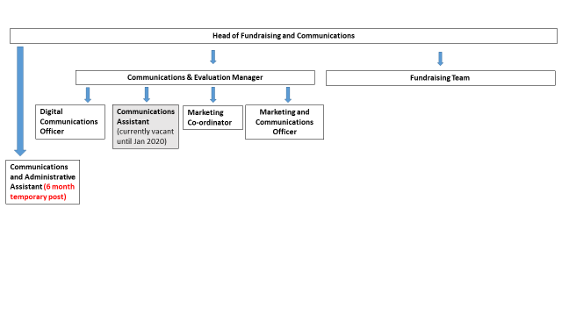

 | Signature | Date
Approved by HR:
Approved by line manager:
Approved by job holder:

Terms and conditions of service
Job Title
Communications and Admin Assistant (Fixed term for 6 months)

Reporting line
This post reports to Head of Fundraising and Communications

Salary
The salary for the post is YMT Scale 3, SCP 14-17, £17,997 to £19,258 pro rata.

Probationary period
Appointments are subject to the successful completion of a six-month probationary period.

Health
Prospective employees must be cleared by the Occupational Health Service as medically fit for employment by the Trust.

Annual leave
The annual leave entitlement is 25 days per annum pro rata for part time employees, increasing by five days (pro rata) after five years continuous service with the Trust, plus public holidays.

Pension
The Trust belongs to the Local Government Pension Scheme and all new employees are enrolled. It is possible to opt out of the pension using forms available at www.nypf.org.uk.

Hours of work
The hours of work are 37 hours per week, worked over five days.

Period of notice
The period of written notice required for you to terminate this post is one month. The Trust will give you one month’s notice.

