KS3 Victorian Rich and Poor
Museum Trail

This Gallery trail explores the following galleries:

In the First section of the Museum:

The Victorian Parlour and Moorland Cottage
Toy Stories gallery
Shaping the Body
Kirkgate

National Curriculum links

Challenges for Britain, Europe and the wider world 1901 to the present day e.g. the creation of the welfare state
A local history study

Name………………………………………………

Look in the Moorland Cottage and Victorian Parlour.
 | 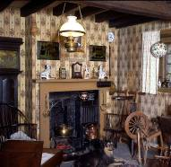 | 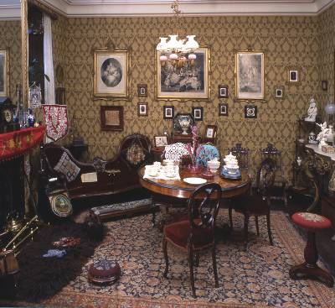
 | Moorland Cottage | Victorian Parlour
How many rooms, including the one you can see, do you think each house would have had?
Why did each of these families have a dog?
Describe how each room is decorated (use plenty of adjectives!)
How would you have spent your time in each room?

Look in the Toy Stories gallery.

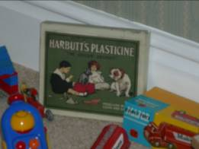
Look in the bedroom display

Find the box of plasticine.

What evidence can you see to show that this was for a rich child to play with?

_____________________________________________________

_____________________________________________________

_____________________________________________________

Find a Victorian clockwork toy and draw it (remember to check your dates!)

Look in the Shaping the Body exhibition

As you go down the stairs, turn left and look in the cases showing Victorian clothes.

All the clothes on display here belonged to richer people.

Why do you think the museum does not have clothes from poorer people to put on display?

- The clothes were too plain and not very interesting so the museum did not save them

- We only save things from rich people – visitors aren’t interested in the poor

- Poorer people could not afford many clothes so wore what they had until they fell apart; they were not in good enough condition to be saved

Find what a rich Victorian boy would have worn until the age of 5.
What type of clothing is it?

_____________________________________________________

Go onto Kirkgate

Go down the passageway between Banks’ music shop and the Little Dust Pan hardware shop. This represents a poorer area of York.

Find the shared toilet and water pump on the right hand side.
Why could this have caused problems for people living nearby?

_____________________________________________________

_____________________________________________________

Leave the passageway and explore Kirkgate.

Fill in the table below:
Name of shop | Used by the rich or the poor? | Why? | Alternative for the poor if used by the rich?
Hardcastle’s Pawnbroker
(see info on next page)
Hansom Cab (horse and carriage)
Kendrick’s Toy Shop
Information on the Pawnbroker
The main function of the pawnbroker was to lend money, although they often traded in second hand goods too.
A customer brings in the items they want to pawn and the Pawnbroker works out the value and how much money they are willing to lend. With the loan agreed, the details are entered in a register and on two tickets. One ticket is given to the customer and the other is attached to the goods. When the customer wants to buy back the item, they hand over their ticket and the payment is made – which includes interest and a ticket fee and the client takes the goods away – until the next time.

Compare the two grocer’s shops:
Ambler’s (for the poor) and Britton’s (for the rich)

Note any similarities or differences between the two including anything showing how you know which class they were used by.
similarities | differences

