KS2 Victorian Rich and Poor
Museum Trail

Teacher’s Notes

This Gallery trail explores the following galleries:

In the First section of the Museum:

The Victorian Parlour and Moorland Cottage
Toy Stories gallery
Shaping the Body
Kirkgate

National Curriculum links:
History:
Pupils should continue to develop a chronologically secure knowledge and understanding of British, local and world history
They should note connections, contrasts and trends over time and develop the appropriate use of historical terms.
They should regularly address and sometimes devise historically valid questions about change, cause, similarity and difference, and significance.
They should understand how our knowledge of the past is constructed from a range of sources.
Pupils should study of an aspect or theme in British history that extends chronological knowledge beyond 1066

Name………………………………………………

Victorian Rich and Poor Trail

Look in the Moorland Cottage and Victorian Parlour.
 | 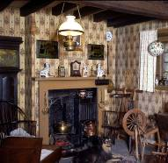 | 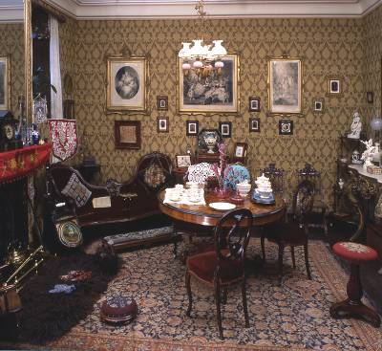
 | Moorland Cottage | Victorian Parlour
How many rooms, including the one you can see, would each house have had?
Why did each of these families have a dog?
How would you have spent your time in each room?
Describe how each room is decorated (use plenty of adjectives!)

Look in the Toy Stories gallery.

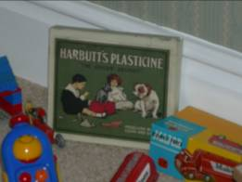
Look in the bedroom display

Find the box of plasticine. What evidence can you see to show that this was for a rich child to play with?

---------------------------------------------------------------

---------------------------------------------------------------

Find a Victorian clockwork toy and draw it (remember to check your dates!)

Look in the Shaping the Body exhibition

As you go down the stairs, turn left and look in the cases showing Victorian clothes.

The clothes on display here all belonged to richer people.

Why do you think the museum does not have clothes from poorer people to put on display?

- The clothes were too plain and not very interesting so the museum did not save them

- We only save things from rich people – visitors aren’t interested in the poor

- Poorer people could not afford many clothes so wore what they had until they fell apart; they were not in good enough condition to be saved

Find what a rich Victorian boy would have worn until the age of 5.
What type of clothing is it?

_____________________________________________________

Walk into Kirkgate

Go down the passageway between Banks’ music shop and the Little Dust Pan hardware shop. This represents a poorer area of York.

Find the shared toilet and water pump on the right hand side.
Why could this have caused problems for people living nearby?

_____________________________________________________

_____________________________________________________

Leave the passageway and explore Kirkgate.

Fill in the table below:
Name of shop | Used by the rich or the poor? | Why?
Second-hand clothes shop (near Ambler’s grocer)
Hansom Cab (horse and carriage)
Kendrick’s Toy Shop
Compare the two grocer’s shops:
Ambler’s (for the poor) and Britton’s (for the rich)

Note any similarities or differences between the two including anything showing how you know whether they were used by the rich or poor.
similarities | differences

