**KS1 Homes Trail**

This Gallery trail explores the following galleries:

In the First section of the Museum:

Period Rooms

The 1950s Front Room

1940s and 1980s kitchens

Kirkgate

**National Curriculum links:**

**History:**

They should ask and answer questions, choosing and using parts of stories and other sources to show that they know and understand key features of events. They should understand some of the ways in which we find out about the past and identify different ways in which it is represented.

Pupils should be taught about changes within living memory. Where appropriate, these should be used to reveal aspects of change in national life

Name………………………………………………

**Homes Trail**

Look in the **Moorland Cottage**

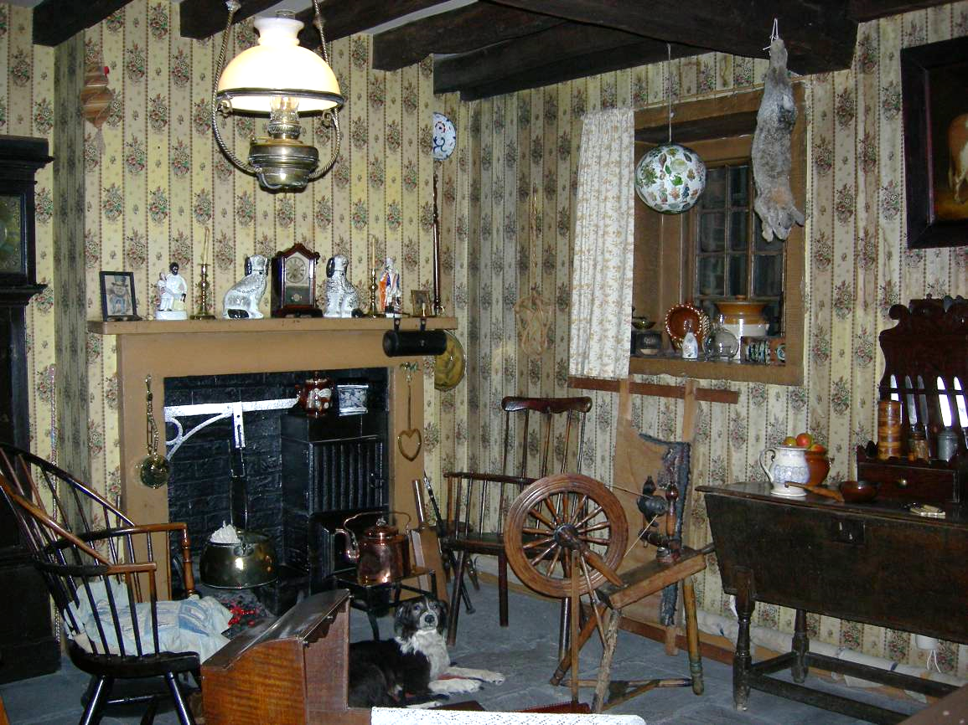

3

1

2

Draw and label what is missing in the picture.

3

2

1

3

Look in the **Victorian Parlour**

Name two hobbies could you have had if you lived here.

…………………………………………………………………

…………………………………………………………………

Look in the **Georgian Room**

Look at the items on the window ledge.

What do you think the person who lived here liked to do?

……………………………………………………………………………………………………………………………………

Look in the **1700s Dining Room**

The furniture in here is all made from the same material.

What is it?

…………………………………………………………………

Which materials is your furniture at home made from?

…………………………………………………………………

…………………………………………………………………

Look in the **1950s Front Room**

Spot 3 objects which use electricity.

Use the word bank to help you.

MCj02904960000[1]

1

**Word Bank**

Lamp

Playstation

Washing Machine

TV

CD player

Fire Radio

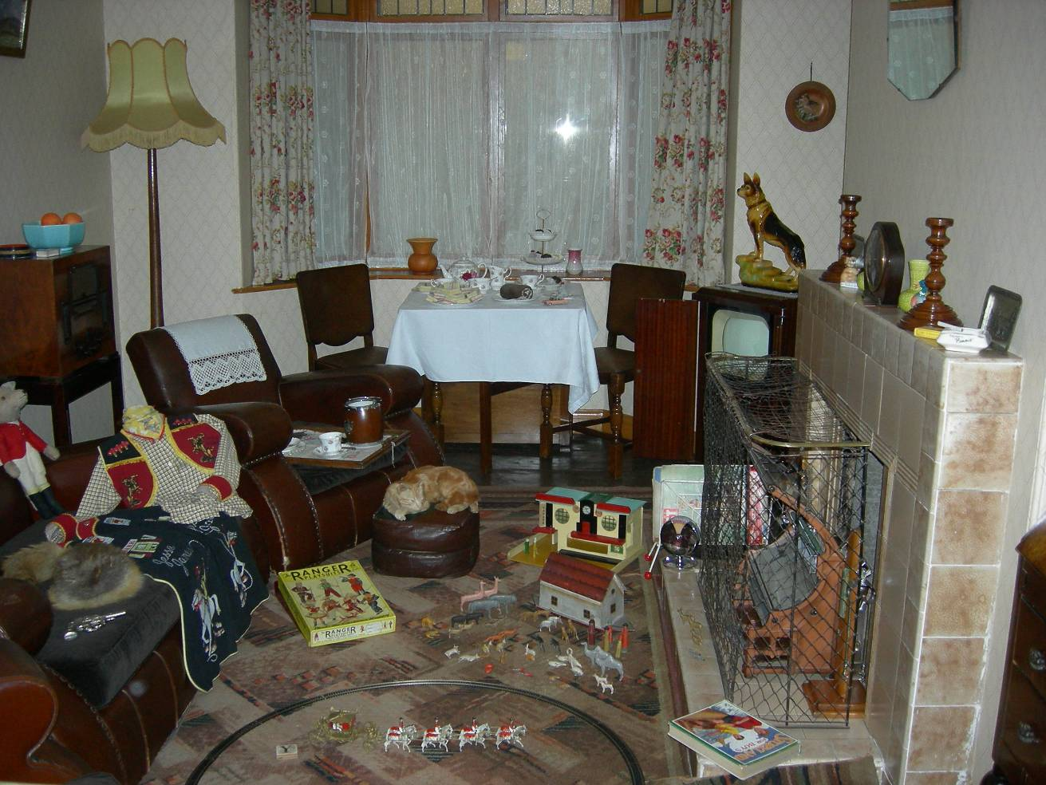

2

1.

2.

3.

Name two things you have at home that use electricity that you would not have had if you lived in the 1950s.

1. ……………………………………………………………
2. ……………………………………………………………

3

Go through the galleries until you can see the 1940s and late 20th century kitchens side by side.

Some things are the same in these two kitchens and some are different.

Write or draw some here:

|  |  |
| --- | --- |
| the same | different |
|  |  |

Look in the **home on Kirkgate**

People who lived in a home like this would have used a toilet like the one behind you near the top of the alleyway.

A toilet would have been shared between about six families. Yuk!

Where did they get their water from?

…………………………………………………………………

How did they light their home?

candles torches electric lights

How would you feel if you had to live here?

…………………………………………………………………

…………………………………………………………………