**KS2 Numeracy Trail on Kirkgate**

This Gallery trail explores

Kirkgate, the Victorian Street

**National Curriculum links:**

At Year 3 pupils should be taught to:

* recall and use multiplication and division facts
* solve problems involving multiplication and division
* recognise, find and write fractions
* tell and write the time from an analogue clock
* recognise angles as a property of shape or a description of a turn
* present data using tables

At Year 4 pupils should be taught to:

* count in multiples
* add and subtract numbers with up to 4 digits
* solve problems involving multiplying and adding
* estimate different measures
* read, write and convert time between analogue and digital clocks
* identify acute and obtuse angles and compare and order angles up to two right angles by size
* identify lines of symmetry

At Year 5 pupils should be taught to:

* add and subtract numbers mentally with increasingly large numbers
* multiply and divide numbers mentally drawing upon known facts
* solve problems involving addition, subtraction, multiplication and division

At Year 6 pupils should be taught to:

* solve problems involving addition, subtraction, multiplication and division
* recall and use equivalences between simple fractions and percentages

Name………………………………………………………………………

Find **T Cookes Scientific Instruments**

Which object is spherical?

_______________________________________________

Find **Banks’ Music shop**

Look on the top two shelves only. How many instruments do you blow?

_______________________________________________

How many is that as a fraction of all the instruments on those shelves?

_______________________________________________

Can you simplify this fraction?

_______________________________________________

Find **Horsley’s Gunsmith**

What is the most common shape of packaging in this window?

Find **Edward Allen’s Taxidermy shop**

Look at the tray of eggs

Using only the eggs you can see in the tray, could you make each section have the same number of eggs in it?

_______________________________________________

Why / why not?

_______________________________________________

_______________________________________________

Find the **Temperance Cocoa Room**

Write the time on the clock as an analogue and a digital readout

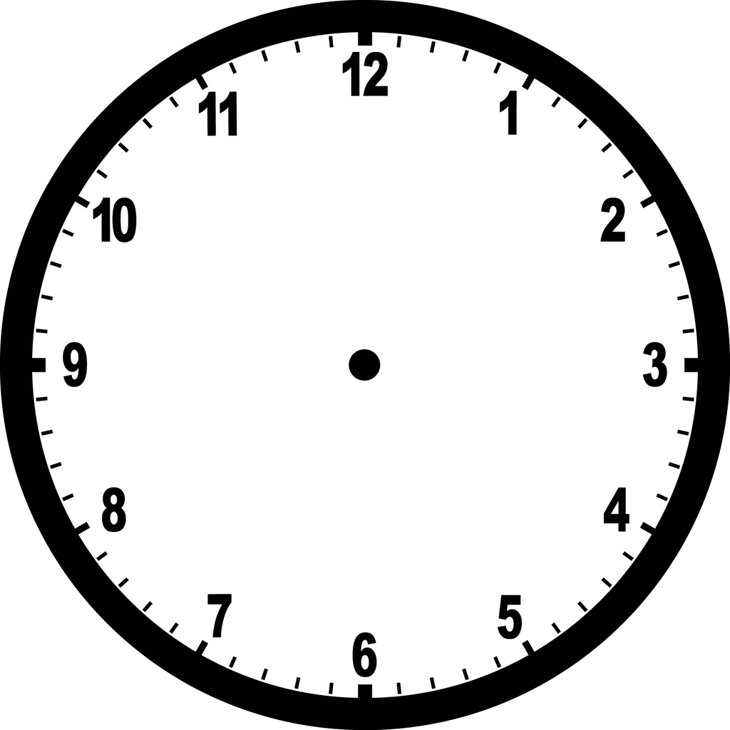

:

Find **Henry Hardcastle Pawnbroker**

What year was the shop established?

_______________________________________________

How long had it been open in 1901?

_______________________________________________

How many windows in the Pawnbroker’s shop altogether (not including those in the doors).

Don’t count – calculate (think multiplication and doubling)!

_______________________________________________

Find **E & A Plummer Milliners**

Could the hats be arranged in equal rows of four to alter the display?

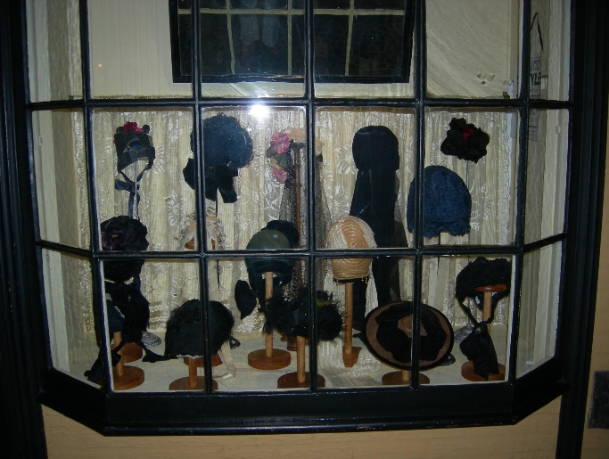Explain your answer

Find the **Horse Repository (where the horse bridles are hanging)**

Find the bicycle at the rear of the space.

If the large wheel turns once, estimate how many times the smaller wheel would have to turn.

_______________________________________________

Find **Leak and Thorp Drapers**

How many umbrellas in the window have black handles?

_______________________________________________

What is this as a fraction of all the umbrellas?

_______________________________________________

And as a percentage?

_______________________________________________

Find the **Tobacconist**

Estimate the height of the Highlander model standing outside the shop.

_______________________________________________

Find **Britton’s Grocer**

Find the tins of apricots.

There are three tins at the bottom of the stack and six tins altogether.

If there were four tins at the bottom, how many tins would be needed to keep the same triangular shape of display?

What if there were five tins at the bottom?

Find the large cheese on the bottom shelf. Draw and estimate the fraction of cheese that makes up the slice.

Find **John Saville Pharmaceutical chemist**

Ignoring the white jar of leeches, how many round jars are on the top shelf?

How many cylindrical jars?

Write this as the proportion of round jars to cylindrical jars.

Can you simplify this?

Fill in the table of bottles on the back shelf

|  |  |  |
| --- | --- | --- |
|  | green | blue |
| clear |  |  |
| ridged |  |  |

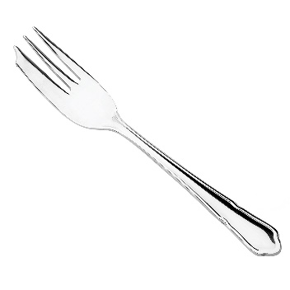Find **Allison Cutlers**

Find the cake forks on the top shelf.

How many boxes would 20 people eating cake need?

Would there be any forks spare and why / why not?

Find **Barton’s Sweet Shop**

Look through the right hand side window at the bottom shelf on the right hand side. The jars are labelled ‘pipes and Rocks’.

If these jars cost 4 pence each, how much would buying all the jars on this shelf cost?

Extension question!

There are 12 pence in a shilling; write your answer in shillings and pence

Find **Greenwoods Antiques Shop**

Draw a symmetrical object (the symmetry does not have to include the pattern or colouring, just the shape). However, there are some truly symmetrical objects to find and draw.

Write the times from two clocks you can find in Kirkgate.

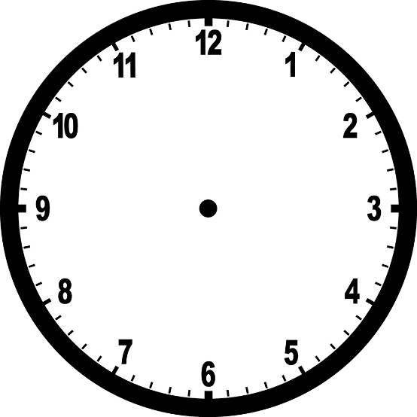 

What is the time difference between the two times?

Extension question!

Draw objects you can find with:

|  |  |
| --- | --- |
| an acute angle |  |
| an obtuse angle |  |
| a right angle |  |

Don’t forget to mark the angles!