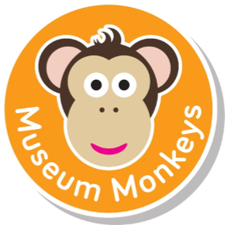
Fun for under 5s
Sessions are now FREE! Museum admission applies for adults. (Free admission for under 5s) Booking Essential
Get 12 months unlimited access to York Art Gallery, York Castle Museum and Yorkshire Museum with a YMT Card.
Sessions run term time only.

Early Years Explorers (two – five years old) Thursdays, 10am – 11am
Activities for children aged two to five years old which include songs, stories, games and craft activities. Sessions are based on familiar preschool play areas, which are enhanced to help children learn about the museum’ collections and exhibitions through play. Sessions are a mixture of free flow and adult led activities which all relate to the Early Years curriculum.
Early Year Explorers
York Art Gallery
Wood
19th April
Feel the textured wood in the sensory area and play with traditional wooden toys.
Cloth
26th April
Discover the different texture cloth, play with rag dolls and make a den with the materials.
Fur & Feathers
3rd May
Clay
10th May
Play in the fur and feather investigation area and listen to animal sounds.

Paper
17th May
Play in the shredded paper area and investigate how to crinkle, rip and roll paper.

Museum Baby (under two years old) Fridays, 10am – 11am
Special baby sessions linked to exhibitions, including songs and sensory activities for babies and their carers. Sessions are a mixture of free flow and adult led activities which all relate to the early years Curriculum. A perfect introduction to museums!
Museum Baby
Castle Museum
Edwardian
20th April
Play with the Punch and Judy set and try on the Edwardian hats.
Dick Turpin
27th April
Try on the tricorn hat and listen to the Highway rat story.
Soldiers
4th May
Knock down the toy soldiers skittles and try on the soldier’s hat.
The Body
11th May
Try on some costumes and discover the new shaping the body exhibition.
Victorians
18th May
Dress as a Victorian and listen to the Victorian wash day story.

HOW TO BOOK
Please book sessions using our Eventbrite page, follow this link: http://tinyurl.com/oh46tnj
Please Note: If you are unable to attend please cancel your booking to allow others to participate.

