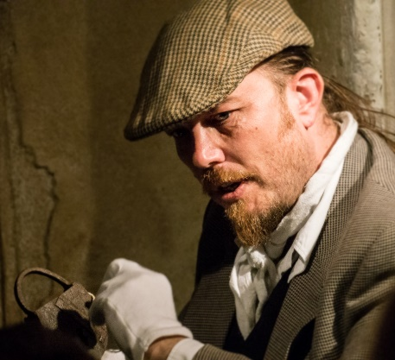
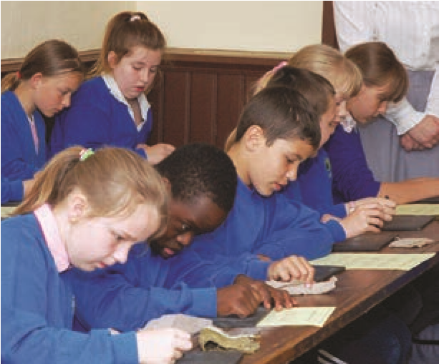
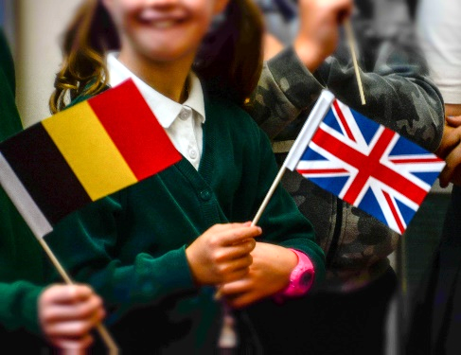
York Museums Trust
TEACHERS
GUIDE
for
TO MAKE A BOOKING: T: 01904 687 633
|
E: groupbookings@ymt.org.uk
|
www.yorkmuseumstrust.org.uk

Organising your students
Your party should be divided into small groups, with each small group supervised by an adult at all times. Please make sure that you are within our adult to child ratios throughout your visit.

When students are making notes or sketching, please leave space for other visitors to see the exhibits. Remember that although we love excited and enthusiastic groups, some of our visitors prefer a quieter environment, so please try to keep noise to a minimum and walk sensibly through the museum.

As the Museum is large, you are advised to select the displays that are most relevant to the work in school.
The galleries are:
Period Rooms
Toy Stories
Shaping the Body
Kirkgate, the Victorian Street
1914: When the World Changed Forever
Exercise Yard and Raindale Mill
60s Gallery
The Prison Exhibition

Photography
Photography for personal use is permitted but please do not bring tripods and equipment with trailing flexes.
Light Levels
Textiles and other fragile materials fade when exposed to bright light, so some areas of the Museum are dimly lit.
Cloakroom
We regret that there is no provision for leaving luggage and coats unless you have booked a workshop.
Toilets
There are toilets including accessible toilets at both sides of the ground floor of the Museum.
Refreshments
There is space to eat picnics in the open air on a grassy area by Raindale Mill or outside the front of the museum.
An indoor lunch room is available for school parties if pre-booked.
Shop
A wide range of quality educational material that supports KS1 and KS2 is available in our shop. There are also affordable souvenirs and gifts for all ages.
Trails
A selection of trails for pupils to use which visiting the museum are available on our website or just ask for more information.

The Galleries
York Castle Museum’s galleries are in two three-storey, former prison buildings. These 18th century, Grade 1 listed buildings are joined by a one storey 20th century building, the Concourse. If you have students who have limited mobility, only the ground floors of both buildings are accessible. Please remember, that in order to comply with fire regulations, there is a one-way system through most galleries. The gallery areas are listed in the order that they are seen.

The Female Prison Building (North Building)
CLIMB THE STAIRS TO THE PERIOD ROOMS.

VICTORIAN PARLOUR (c 1870)
A room such as this would have belonged to a wealthier Victorian family. There are lots of showy items such as the elaborate ceiling rose (where the gas lamp attaches to the ceiling), the glassware and the tea set. Rich Victorians liked their rooms cluttered with as much evidence of obvious wealth as possible and items such as the silk flowers in the vase would have been bought from Harrods at the equivalent in today’s money of about £45 each! They would have had staff in the house and this is evidenced by the pull cord by the fireplace used to summon a maid.

MOORLAND COTTAGE (c 1850)
This room shows how a rural family would have lived with a single room to house everyone. There may have been another room but that would have been used for livestock only, so every member of the family would have eaten, slept, bathed and lived their daily life in this one room. This family would not be very poor as they have some ornaments and trinkets, but the bed dates from an earlier period, showing that it would be an heirloom to be passed on through the generations. A large witch ball hangs in the window to scare away evil spirits – a practice dating from a much earlier period, but showing that there was still much superstition around.

GEORGIAN ROOM (c 1780)
The dolls’ house in this room is one of the earliest dolls’ houses in the country, with furniture dating from c.1700. The other objects in the room suggest an enlightened family, with glasses to read the newspaper and a telescope nearby. The candles on the back wall have glass panels behind them to help to reflect the light back into the room.

17th CENTURY DINING ROOM
Although this room looks dark to us today, the wood was originally much lighter and has darkened with age.
The table is set with a variety of food ready to be enjoyed by a wealthy family, possibly entertaining guests. Food was used to show wealth; items such as large pies and whole roast birds were a wonderful way to show that you felt your guest was important. The large book to the left hand side is the family bible and dates from 1674.
CLIMB THE STAIRS TO THE 1950S FRONT ROOM AND THE TOY STORIES GALLERY.
The Female Prison Building (North Building) Continued...
In this gallery, you can pick up a free Teddy Bear Trail bookmark and follow the clues to find where the bear is hiding.

1950s ROOM
It is clearly someone’s birthday here with new toys and wrapping paper everywhere. The toys here are simple toys which needed a good imagination to be played with, such as dressing up clothes, toy cars and a walkie talkie. There is a small television in the corner which would have been the pride and joy of this family as they were luxury items; it would probably have been bought to watch the Queen’s Coronation in 1953.

TOY STORIES GALLERY
The Toy Stories gallery contains toys and games from the past 150 years. Opposite the 1950s room is a carousel from 1905 which was pulled round the streets of West Yorkshire by a horse. Small children paid a penny each to go on it, but could pay in rags or empty jars if they did not have the money.

WALK DOWN THE STAIRS TO ‘SHAPING THE BODY’, WHICH SHOWS HOW BODY SHAPE HAS CHANGED THROUGH COSTUME, DIET AND LIFESTYLE.

SHAPING THE BODY
Entering this gallery leads you to the catwalk straight ahead. This guides you down to one of our star items – a Georgian wedding dress. You then follow the evolution of costume from the 1700s through the Victorian era and the 20th century to thoughts on future fashion. There is then the chance to listen to the stories of real people speaking about the relevance of what they wear, whether they are punks, transgender or wearing retro chic. There is also a cabinet on dangerous fashions including an arsenic infused dress and some killer high heels.

At the foot of the stairs is an area on food and how it has changed along with our attitudes towards what we eat and the affect it has on us. There are some Roman human remains on show here, but you can walk straight past them if you choose to.

CLIMB THE STAIRS TO THE KITCHEN AREA.

This area looks at different ways of cooking from the open hearth to the microwave.

1940s KITCHEN
This kitchen dates from the late 1940s. The electric cooker is a 1935 model and was rented from York City Electricity Department. It was quite common to rent the larger domestic appliances because they were expensive to buy. The pantry houses a range of convenience foods, which were beginning to become more available after the Second World War. Rationing was still in operation; it ended completely in 1954.
1980s KITCHEN
Fitted cupboards, wall tiles, floor covering and the decoration of the kitchen all complement each other to achieve a ‘total look’. Fitted kitchens were first designed in the late 1950s. There are many small electrical appliances which are now regarded as essential items for a kitchen. The microwave oven became popular in the early 1980s having been developed from the discovery of radar in the Second World War.

There are also open hearths and preservation equipment displayed here.

WALK DOWN THE STAIRS TO THE LIFESTYLE AREA.

This area shows the development in lifestyles over the past 150 years. On display are exercise equipment, bicycles (including a wonderful tandem that ladies in larger dresses could have ridden) along with ‘talking heads’ and information comparing the same jobs then and now.

WALK DOWN THE STAIRS INTO KIRKGATE. THERE ARE TOILETS AT THE START OF THE STREET.

KIRKGATE STREET
York Castle Museum is famous for its Victorian street, Kirkgate, which we have recreated to show what York was like between 1870 and 1901. All the shops are based on real shops in York and any characters referred to were all real people. Some of the shops may be staffed by our volunteers. There should also be costumed guides on the street - do talk to the guides and volunteers, they're very knowledgeable.

WALK DOWN THE STAIRS TO THE CONCOURSE. WALK PAST THE FRONT ENTRANCE,
THROUGH THE SHOP THEN UP THE STAIRS TO YOUR RIGHT. THERE ARE TOILETS HERE.
(OR FOR AN ACCESSIBLE ENTRANCE, THROUGH THE SHOP AND DOWN THE RAMP IN FRONT OF YOU TO THE LIFT).

The Debtors’ Prison Building (South Building)

1914: WHEN THE WORLD CHANGED FOREVER
In this exhibition you can see a snapshot of York at the start of the Edwardian period before war broke out in 1914, before visiting the Recruitment Office to ‘join up’. A train carriage transports you to the Front and a replica British trench complete with rats. You then you cross No Man’s Land and enter a German trench and are faced with a tank looming above you. Your journey takes you via communication and medical advances through to the Eastern Front before concluding with the end to war and remembrance. There are also temporary exhibitions in this gallery on a variety of themes all linked to the era.
LEAVE THE EXHIBITION AND GO DOWN STAIRS TO THE EXERCISE YARD.

EXERCISE YARD AND MILL AREA
This area was the original Debtors’ Prison Exercise Yard. On fine days there may be old-fashioned games to play here.
As you enter the area, the repaired bailey wall is to your right. To your right is the South East Tower. You walk through the 13th century South Angle Tower, past the site of the South Gate and the drawbridge, on your way to Raindale Mill, an area lovely for picnics. Apart from this section of the bailey wall, all that remains of York Castle is the keep, known as Clifford’s Tower, which is maintained by English Heritage.
LEAVE THE EXERCISE YARD BY THE DOOR AT THE FAR END AND ENTER THE SIXTIES GALLERY.
05
The Debtors’ Prison Building (South Building) Continued...

SIXTIES GALLERY
Here you can see a wide variety of items from the 1960s, from Beatles memorabilia and a scooter to those everyday items such as a dinner service. There is also a life-size replica of the Mercury Space Capsule that John Glenn used to orbit the earth in 1962 which you can sit inside.
LEAVE THE SIXTIES GALLERY AT THE FAR END AND ENTER THE PRISON EXHIBITION.

PRISON EXHIBITION
The cells here have been recreated to look as they did in the 18th century. There are projected films telling the stories of staff and inmates including the infamous Dick Turpin. The area is dark, as it would have been, with lower ceilings than the modernised parts of the building.
In the cells further into the Prison Exhibition, you can find out about the history of York Castle and prison in our short film ‘1000 Years of Justice’ which is projected on to the floor of one of the larger rooms. You can also hear poetry written by those incarcerated here and even find out whether you had an ancestor locked up in York Prison.
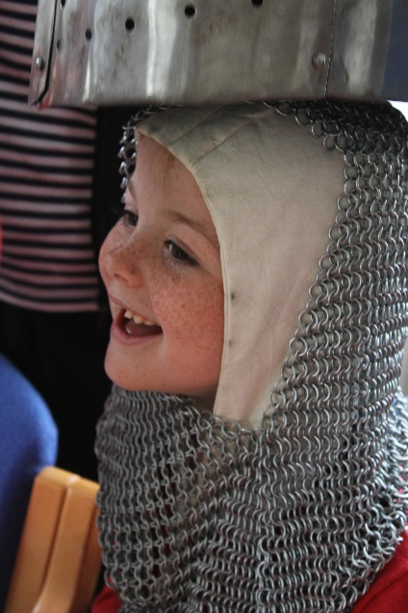
LEAVE THE PRISON AT THE FAR END VIA THE TOILET AND SHOP AREA AND RETURN TO THEMUSEUM ENTRANCE.

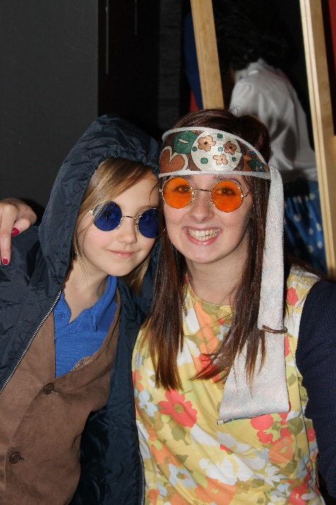
Remember we run over twenty school workshops too!
