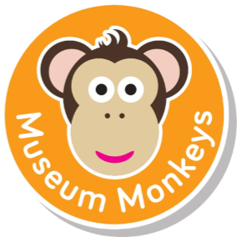
Fun for under 5s
Only £4 per session. Museum admission applies.
Get 12 months unlimited access to York Art Gallery, York Castle Museum and the Yorkshire Museum with a YMT Card. (Museum Monkeys sessions are free for holders of a York Resident’s Access YMT Card)
Sessions run term time only.
Early Years Explorers (two – five years old) Thursdays, 10am – 11am
Activities for children aged two to five years old which include songs, stories, games and craft activities. Sessions are based on familiar preschool play areas, which are enhanced to help children learn about the museum’ collections and exhibitions through play. Sessions are a mixture of free flow and adult led activities which all relate to the Early Years curriculum.
Early Years Explorers
York Art Gallery
Portraits
9th November
On Gallery special. Spot the portraits in the Burton Gallery. Try on hats and look in the mirrors to draw a self-portrait. Listen to the hats story.
Pottery
16th November
On Coca Gallery special. Find the pots in the trail, handle pots and listen to the story of the clay boy.
Animals in Art
23rd November
Spot the animals in the art gallery, play with the animal toys and make an animal collage.
Flowers
30th November
Find flowers in the art gallery, make flower print paintings and listen to the flower story.
Landscapes
7th December
On Gallery special. Listen to the landscape sounds, play with the felt landscape and farm animals.

Museum Baby (under two years old) Fridays, 10am – 11am
Special baby sessions linked to exhibitions, including songs and sensory activities for babies and their carers. Sessions are a mixture of free flow and adult led activities which all relate to the early years Curriculum. A perfect introduction to museums!
Museum Baby
Castle Museum
Chocolate
10th November
Chocolate shop role play area, doughnut soft play area and listen to the chocolate story.
Sweet Treats
17th November
Listen to the story of the gingerbread man, colour in a gingerbread man and play in the cake shop role play area.
Sweets
24th November
Listen to the story of the gingerbread man, colour in a gingerbread man and play in the cake shop role play area.
WW1 Animals & Transport
1st December
Play with the tanks in the sand and play with the toy horse.
Christmas Specials –Castle Museum
Museum Baby 8th December Early Years Explorers 14th December
Be an elf and help Santa to pack the toys, go down the chimney like Santa, and find the stars in the Reindeer food.

HOW TO BOOK
Please book sessions using our Eventbrite page, follow this link: http://tinyurl.com/oh46tnj
Please Note: If you are unable to attend please cancel your booking to allow others to participate.

