KS2 First World War trail
Museum Trail

Teacher’s Notes

This Gallery trail explores the following galleries:

The Second section of the Museum:

1914: When the World Changed Forever

National Curriculum links:
History:
Pupils should continue to develop a chronologically secure knowledge and understanding of British, local and world history
They should note connections, contrasts and trends over time and develop the appropriate use of historical terms.
They should regularly address and sometimes devise historically valid questions about change, cause, similarity and difference, and significance.
They should understand how our knowledge of the past is constructed from a range of sources.
Pupils should study of an aspect or theme in British history that extends chronological knowledge beyond 1066

Name…………………………………………………………….

First World War Trail

Go through the shop and up the stairs to the exhibition 1914: When the World Changed Forever

The first room shows you aspects of life in Edwardian York and follows on in time almost immediately from life shown at the end of Kirkgate, the Victorian street.
Name two things you can see in this room that you would not be able to find on a Victorian street.
1. ______________________________________
2. ______________________________________

Look at the large map of Europe and the surrounding countries.
Are all the countries represented in a positive way?
Yes No

Extension question:
Why do you think this is?
_________________________________________
Do you think the nationality of the artist had an influence on what they drew? Why / why not?
_________________________________________
Go to the Recruitment Office where the desk is.

In the first room there is a red soldier’s uniform but all the uniforms in the Recruitment Office are khaki.
What effect did wearing khaki uniforms over red have on troops fighting?
_________________________________________
_________________________________________
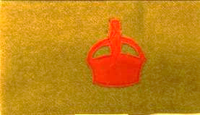
Find this armband

What did wearing this armband mean?
- You were a pacifist and refused to fight
- You had volunteered to help the war effort and were waiting to be called up
- You were part of the Medical Corps

Go into the train carriage.

What did you need to take to war with you for daily life?
_________________________________________

What would it have been a comfort to take with you?
_________________________________________
In the next room, watch the film footage of troops travelling to the Front in 1914. (There is also other footage in the film loop that you may be interested in).

Most of the soldiers are smiling and waving.
Why do you think the footage would look different if the film showed soldiers returning to the Front after they had already served there?
__________________________________________________________________________________

Go into the trench.

There is a case with two flattish tins in front of you; both tins were sent to troops at the Front for Christmas 1914.
Why do you think they were so important to soldiers getting them?
__________________________________________________________________________________

This trench has a stone floor. What would the actual trenches on the Western Front have instead?
_________________________________________

Go into the communication dugout

What sounds can you hear?
1. _______________________________________
2. _______________________________________
3. _______________________________________
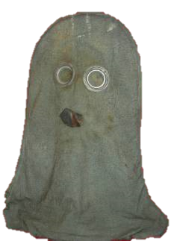

Find this item

What was it used for?
_________________________
_________________________
_________________________

Go into the room with the large picture painted on the wall.

Compare the soldier’s faces to those on the film you saw going to war.

How do you think they are feeling now?
_________________________________________

After crossing ‘No Man’s Land’ you enter a German trench.

How does it look different to the English trench?
__________________________________________________________________________________

The First World War was not just fought in Europe. Name one other country where they fought.
_________________________________________

Look in the Medical dugout.

Which X-ray shows a hand with a bullet in?

1 2 3

There are galleries to your right which have displays and film footage in.
Please take your time to explore them.

Go past the tree and into the room on your left.

What is ‘trench art’?
__________________________________________________________________________________

Which of these is a piece of trench art on display here?

candlestick medal helmet

Who or what were Pip, Squeak and Wilfred?
_________________________________________

In the next room there is space on the wall for you to write a thoughtful message for others. Look at what other visitors have written and discuss as a group what you would like to write (if anything).

Think about what you have seen and heard in the exhibition.
How has it made you feel?
____________________________________________________________________________________________

