KS2 Victorian Rich and Poor
Museum Trail

Teacher’s Notes

This Gallery trail explores the following galleries:

In the First section of the Museum:

The Victorian Parlour and Moorland Cottage
Toy Stories gallery
Shaping the Body
Kirkgate

National Curriculum links:
History:
Pupils should continue to develop a chronologically secure knowledge and understanding of British, local and world history
They should note connections, contrasts and trends over time and develop the appropriate use of historical terms.
They should regularly address and sometimes devise historically valid questions about change, cause, similarity and difference, and significance.
They should understand how our knowledge of the past is constructed from a range of sources.
Pupils should study of an aspect or theme in British history that extends chronological knowledge beyond 1066

Name………………………………………………

Victorian Rich and Poor Trail

Look in the Moorland Cottage and Victorian Parlour.
 | 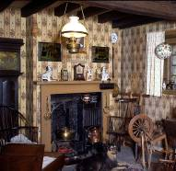 | 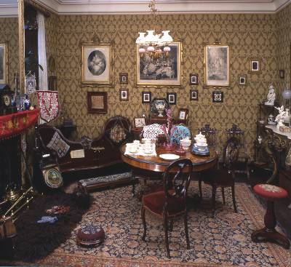
 | Moorland Cottage | Victorian Parlour
Why did each of these families have a dog?
How many rooms, including the one you can see, would each house have had?
Where would food have been prepared in each house?
How would you have spent your time in each room?

Look in the Toy Stories gallery.

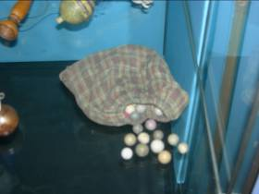
Where would a poor Victorian boy have played with marbles like these?

In the street
In the nursery of their house
In their garden

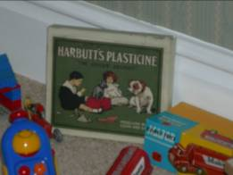
Look in the bedroom display

Find the box of plasticine. What evidence can you see to show that this was for a rich child to play with?

---------------------------------------------------------------

---------------------------------------------------------------

Look in the Shaping the Body exhibition

As you go down the stairs, turn left and look in the cases showing Victorian clothes.

The clothes on display here all belonged to richer people.

Why do you think the museum does not have clothes from poorer people to put on display?

- The clothes were too plain and not very interesting so the museum did not save them

- We only save things from rich people – visitors aren’t interested in the poor

- Poorer people could not afford many clothes so wore what they had until they fell apart; they were not in good enough condition to be saved

Walk into Kirkgate

Shopping!

Imagine you are a rich Victorian.
Which shops could you have visited and what could you have bought
Remember – money is not a problem!

Name of Shop Your Purchase
1.

2.

3.

4.

Imagine you are a poor Victorian.
Which shops could you have visited and what could you have bought
Remember – money is a problem!

Name of Shop Your Purchase
1.

2.

3.

4.

