KS2 Victorian Childhood
Museum Trail

This Gallery trail explores the following galleries:

In the First section of the Museum:

The Victorian Parlour and Moorland Cottage
Toy Stories gallery
Shaping the Body
Kirkgate

National Curriculum links:
History:
Pupils should continue to develop a chronologically secure knowledge and understanding of British, local and world history
They should note connections, contrasts and trends over time and develop the appropriate use of historical terms.
They should regularly address and sometimes devise historically valid questions about change, cause, similarity and difference, and significance.
They should understand how our knowledge of the past is constructed from a range of sources.
Pupils should study of an aspect or theme in British history that extends chronological knowledge beyond 1066

Name……………………………………………………………
Victorian Childhood Trail

Look in the Moorland Cottage
What materials are all the toys in here made from?
How would children in this family have spent their time helping with tasks?

1.

2.

3.
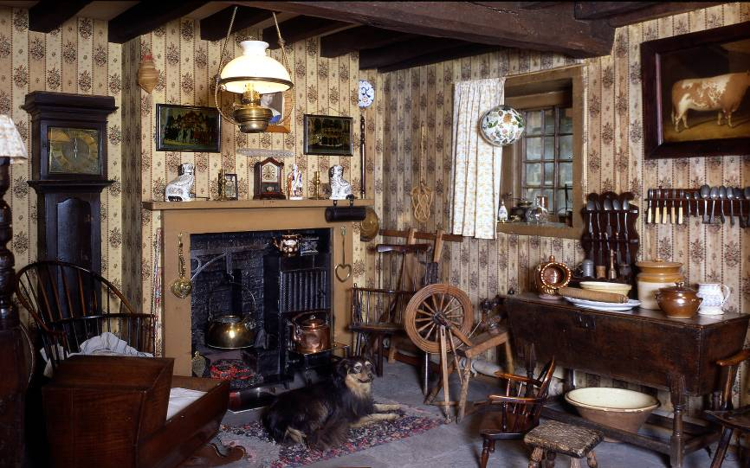

Can you spot a bath?

Look at the Victorian Parlour
Find evidence of hobbies:

1.

2.

3.
There is only one toy in here. What is it?

Where are the other toys in this house?
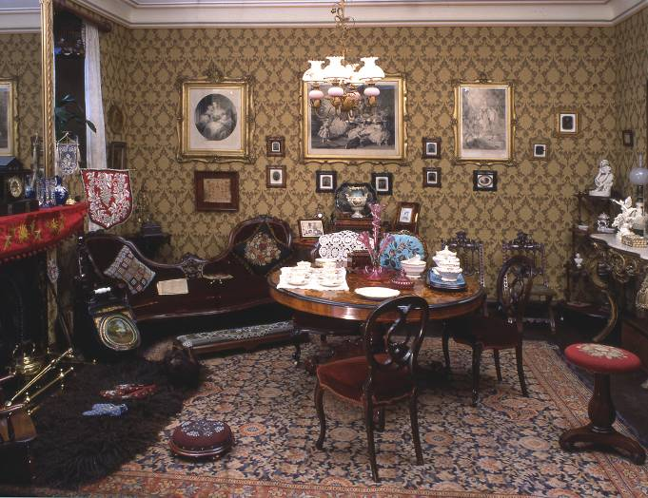

Who is the famous family in the largest picture on the back wall?

_______________________________________________

Look in the Toy Stories gallery

How would a Victorian child make the horse and cart toy move?

_______________________________________________

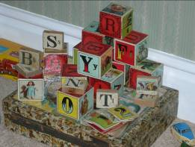
Look in the bedroom display.

Why were alphabet blocks seen as such a good toy by Victorian parents?

_______________________________________________

Find a Victorian clockwork toy and draw it (remember to check your dates!)

Look in the Shaping the Body exhibition

As you go down the stairs, turn left and look in the cases showing Victorian clothes.

There is a small blue dress here – it was for a boy.

Young Victorian boys dressed like many girls do nowadays, mainly wearing dresses and pleated skirts until the age of three or four.

Why do you think this was?

- A fashion choice

- To make potty training easier (nothing to unfasten)

- It was warmer 100 years ago

Walk into Kirkgate

Shopping!

Imagine you are a rich Victorian child.
Which shops could you have visited and what could you have bought
Remember – money is not a problem!

Name of Shop Your Purchase
1.

2.

3.

4.

Imagine you are a poor Victorian child.
Which shops could you have visited and what could you have bought
Remember – money is a problem!

Name of Shop Your Purchase
1.

2.

3.

4.

