**KS2 Swinging Sixties**

**Museum Trail**

**Teacher’s Notes**

This Gallery trail explores the following galleries:

In the First section of the Museum:

The 1950s Front Room

Toy Stories exhibition

The Second section of the Museum:

The Sixties gallery

**National Curriculum links:**

**History:**

Pupils should continue to develop a chronologically secure knowledge and understanding of British, local and world history

They should note connections, contrasts and trends over time and develop the appropriate use of historical terms.

They should regularly address and sometimes devise historically valid questions about change, cause, similarity and difference, and significance.

They should understand how our knowledge of the past is constructed from a range of sources.

Pupils should study of an aspect or theme in British history that extends chronological knowledge beyond 1066

Name…………………………………………………………………

**The Swinging Sixties Trail**

Head upstairs from the Period Rooms to the Toy Stories Gallery

Look at the **1950s Front Room**

This is a living room of a working class family. The family might have watched the Coronation of Elizabeth II on their new television set.

What ornaments can you see?

1.

2.

3.

What materials can you see?

1.

2.

3.

Can you spot what they might have done in their spare time?

1.

2.

3.

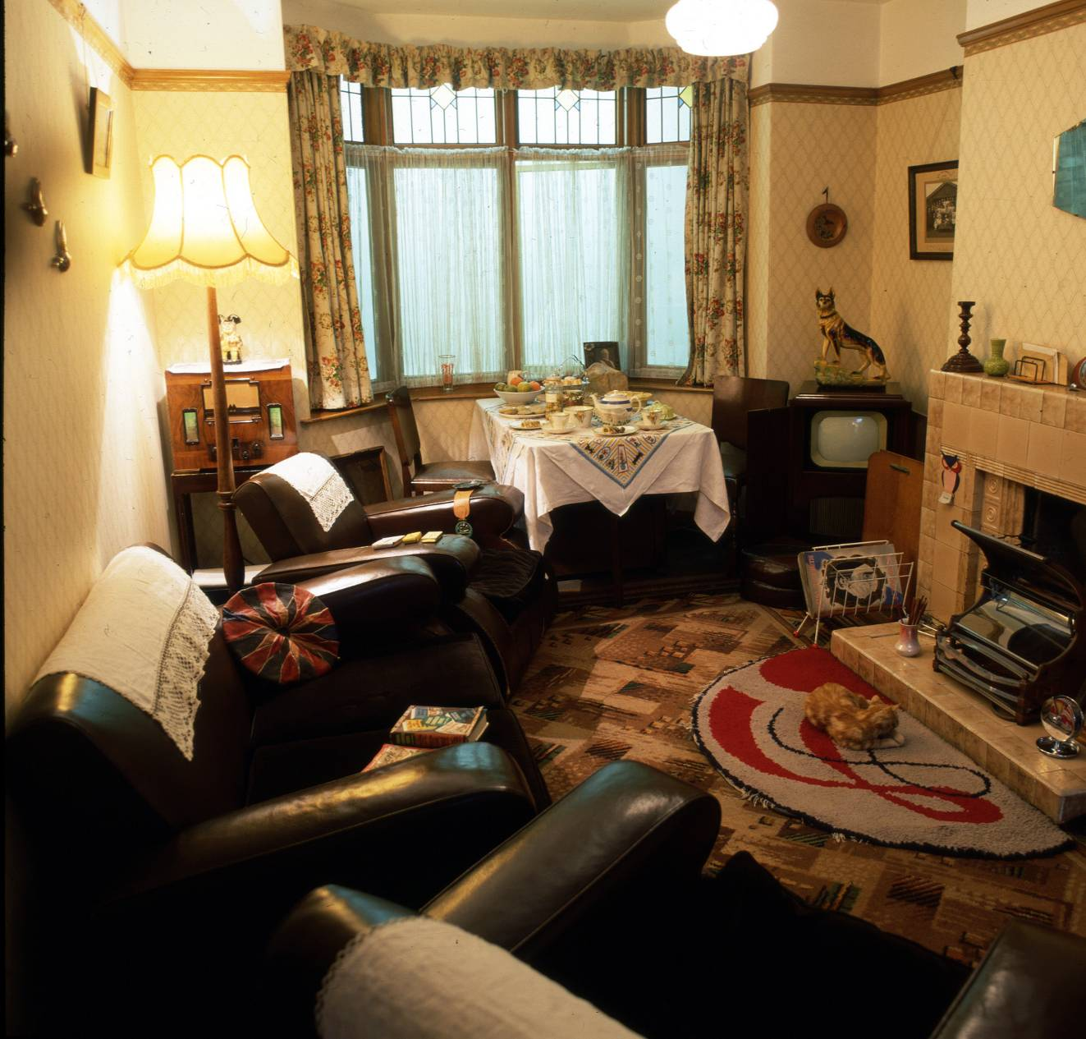

Look at the **Toy Stories Gallery**

Which of these toys on display is from the 1960s?

Rubber duck Mangle Spirograph



None of the computer consoles on display date from the 1960s or earlier. Why? ……………………………………

……………………………………

Look at the **Shaping the Body gallery**

There are clothes from many time periods here – find the 1960s clothes.

Name two materials / fabrics that the clothes you can see are made from.

…………………………………………………………………………

…………………………………………………………………………

**Cross to the other side of the museum past the entrance to the museum.**

Look at the **Sixties Gallery**

Look for the case containing popular music memorabilia.

Find three items of Beatles memorabilia that are not records

1. ………………………………………………………………………

2. ………………………………………………………………………

3. ………………………………………………………………………

Look in the shop area

Find one item of food or confectionery where the packaging remains the same today

…………………………………………………………………………

Find one item of food or confectionery where the packaging is different from the same item today

…………………………………………………………………………