**KS1 Numeracy Trail on Kirkgate**

This Gallery trail explores

Kirkgate, the Victorian Street

**National Curriculum links:**

At Year 1 pupils should be taught to:

* count to 100 from any given number
* count in multiples of twos, fives and tens
* solve one-step problems involving multiplication
* measure and begin to record lengths
* tell the time to the hour and half past the hour
* recognise and name common 2-D and 3-D shapes

At Year 2 pupils should be taught to:

* count in steps of 2, 3, and 5 from 0, and in tens from any number
* order numbers from 0 up to 100
* add and subtract numbers using concrete objects
* solve problems involving multiplication and division
* tell and write the time
* identify and describe the properties of 2-D and 3-D shapes
* interpret and construct simple tally charts,

Name…………………………………………………………………………….

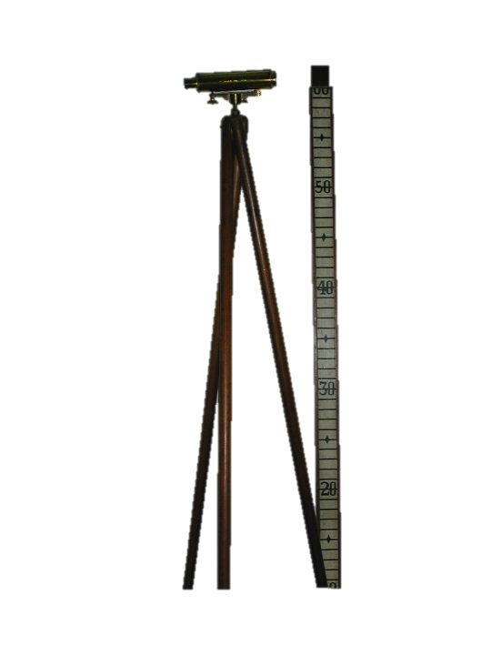**Turn right at the bottom of the stairs that lead onto Kirkgate from the other galleries**

Find **T Cookes Scientific Instruments**

Which number is missing off the top of the measuring stick?

_________________________________________________

Find the **Temperance Cocoa Rooms**

Find the clock. What does V stand for?

_________________________________________________

Find **Horsley’s Gunsmith**

How many different items used for sports can you count? _________________________________________________

Find **Hardcastle’s Pawnbroker**

Is there an odd or even number of walking sticks in the window?

**odd even**

Find **Plummer Milliners**

Look in the left hand side window. How many panes of glass?

Don’t count – calculate (think in fives)

_________________________________________________

Find **Leak and Thorp drapers**

How many coat buttons does the blue jacket in the window have?

_________________________________________________

How many would two coats have?

_________________________________________________

How many on four?

_________________________________________________

Find the **Hansom Cab**

How many squares can you find? Look carefully.

_________________________________________________

Find **John Saville Pharmaceutical Chemist**

What shape is the window above the door?

_________________________________________________

How many bottles have red labels?

_________________________________________________

Looking at the bottles with red labels, what is the difference in number between the green bottles and the clear bottles?

_________________________________________________

Find **Amblers Family grocers**

What numbers in the 20s are missing from the tea tins on the top shelf?

_________________________________________________

Find **Anderson’s Military Outfitters**

Look in the left hand side window. Is there one hat for each jacket?

yes no

Find **Kendrick’s Toy Shop**

Find the shelf with the metal soldiers.

How many soldiers are lying down or kneeling?

_________________________________________________

How many soldiers are standing?

_________________________________________________

How many altogether?

_________________________________________________

Find **Wehrly & Co Clockmakers**

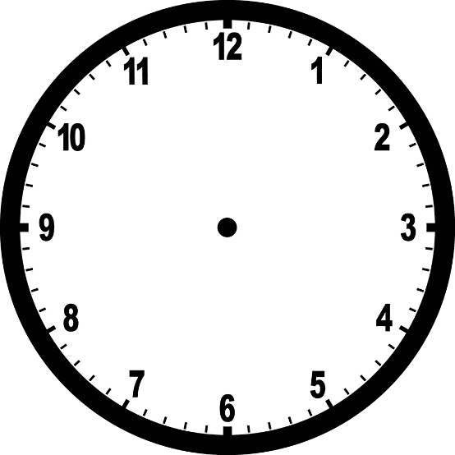

Finda clock showing an o’clock time

Draw and write the time shown.

____________________________

Draw two different shaped windows you have seen on Kirkgate

|  |  |
| --- | --- |
|  |  |

How many wheels can you find on Kirkgate? Use a tally chart to help you.

Wheels usually come in pairs. Can you find some other items in pairs?

_________________________________________________

_________________________________________________



Dr Kirk’s Bonus questions!

Find objects that are the shapes bellow

Circle

Square

Rectangle

Oval

Triangle

Cuboid

Cylinder

How many wheels can you find?

How many pairs is that?

Can you find some other items in pairs?

How many people is the toilet in the yard made for?