KS1 Literacy Trail

This Gallery trail explores:
The Period Rooms
Toy Stories gallery
Shaping the Body
Kirkgate, the Victorian Street

National Curriculum links:
Pupils should be taught to:
- articulate and justify answers, arguments and opinions
- give well-structured descriptions, explanations and narratives for different purposes, including for expressing feelings

At Year 1 pupils should be taught to:
- apply phonic knowledge and skills as the route to decode words
- spell words containing each of the 40+ phonemes already taught
- write sentences by composing a sentence orally before writing it

At Year 2 pupils should be taught to:
- continue to apply phonic knowledge and skills as the route to decode words
- spell by segmenting spoken words into phonemes and representing these by graphemes, spelling many correctly
- consider what they are going to write before beginning by planning or saying out loud what they are going to write about
- develop positive attitudes towards and stamina for writing by writing for different purposes

Name………………………………………………

Look at the Moorland Cottage

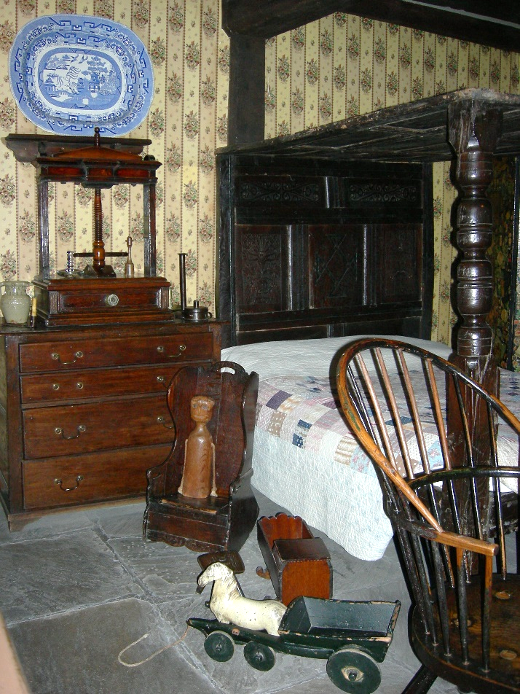
Join the labels to the right object
doll
plate

quilt
horse
bed

chair

Look at the 17th Century dining room

Imagine you are eating a meal here.
How do you feel?
…………………………………………………………………………………………………………………………………….

Find the Toy Stories gallery

Draw your favourite toy in the gallery

Why do you like it?
…………………………………………………………………………………………………………………………………….

Head into the Shaping the Body gallery

Find objects that match these words:
bright
uncomfy
shiny
fluffy

Find the kitchens

Are these things the same or different than in your house?

Look in the 1940s kitchen.
tap | same | different
cooker | same | different
chair | same | different

Look in the 1980s kitchen.
mugs | same | different
microwave | same | different
sink | same | different

Head onto Kirkgate

What do you think when you first see Kirkgate?
…………………………………………………………………………………………………………………………………….

There are lots of noises you can hear on Kirkgate.
Fill in the table with three sounds you can hear.
What can I hear? | Where am I? | What I think it is?

Look all over Kirkgate to find words that rhyme with mat
…………………………………………………………………………………………………………………………………….

Go to the police cell.

Try sitting on the bed with the door closed.
How would you feel if you had to spend the night in this police cell?
…………………………………………………………………………………………………………………………………….

What was your favourite object on Kirkgate?
…………………………………………………………………
Why?
…………………………………………………………………

