**KS1 Chocolate Trail**

This trail looks at chocolates made in York and the families who made them, but also looks at sugar, its uses and our consumption.

This trail leads through the whole museum.

**National Curriculum links:**

**History:**

They should ask and answer questions, choosing and using parts of stories and other sources to show that they know and understand key features of events. They should understand some of the ways in which we find out about the past and identify different ways in which it is represented.

Pupils should be taught about changes within living memory. Where appropriate, these should be used to reveal aspects of change in national life

**Chocolate Trail**

Name………………………………………………

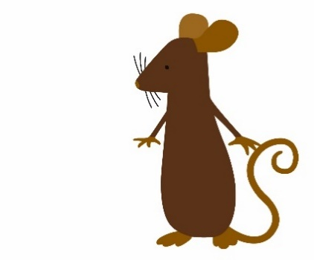

Look out for these mice throughout the museum

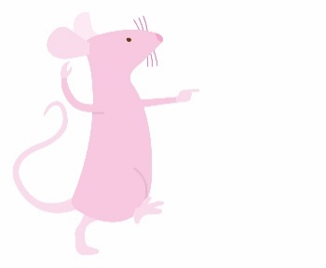

They will tell you things to look for and give you things to think about too.

Including the two at the bottom of the stairs leading up to the Period Rooms, there are lots of mice to spot – can you find them all?

Start at the **Victorian Parlour**



3

Look at the sweets on the table. Some are ‘conversation lozenges’ like this:

­­­­­­­­­­­­­­­­­­­­­­­­­They are sweets with a message on, a bit like Love Hearts today. Write a message on this sweet.

Look at the **Moorland Cottage**

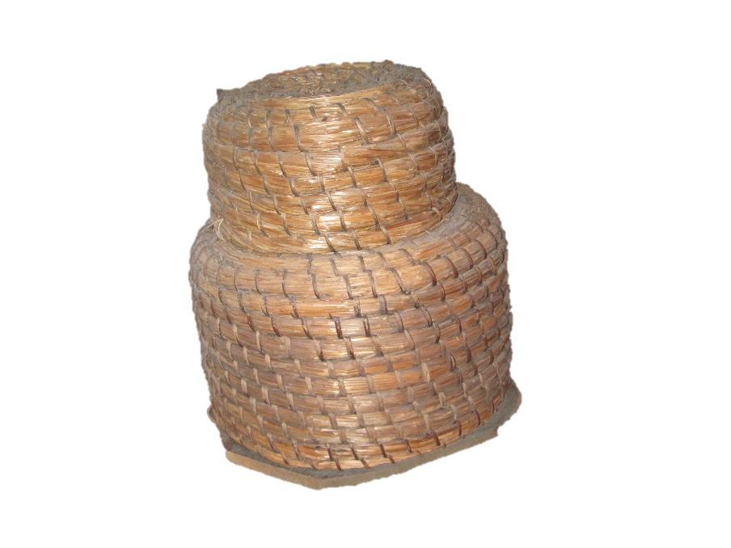

Find the bee skep.

What have bees got to do with sweet food?

______________________________________________

______________________________________________

Look in the **large glass case**

There are lots of different chocolate boxes here.

Some look like eggs, but one look like a pink __ __ __.

Look at the **Georgian Room**

What shape did sugar come in before we got in in bags?

Clue: look on the table.

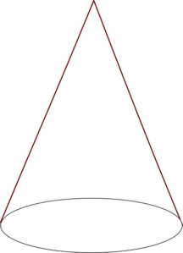

Look at the **17th Century Room**

Not much sugar here – too expensive! Although you might be able to spot a few white sweets on the table.

Before you go upstairs, there is a timeline of when some of the most popular chocolates were first made.

Before the chocolate orange in 1932, there was a chocolate __ __ __ __ __.

Go upstairs to the **Toy Stories Gallery**

We have our own pretend sweet-making machine here.

Does it remind you of one from a chocolatey story?

Can you think of any other stories that are about sweets, sugar or chocolate?

______________________________________________

______________________________________________

Go through the **Shaping the Body Gallery,** upstairs and into the **Chocolate Factory**

In here you can see a map of where the chocolate makers were and are today in York.

There are also photos of sweets and chocolates being made.

What colour rock are Craven’s making?

­______________________________________________

The tests are based on those used by Rowntree’s when looking for new staff.



Getting the loop round the mouse shape shows you have a steady hand and would be suited to jobs like piping chocolate (you may see a film of this in this space too).

Getting the shapes in the holes quickly shows you would have been good at packing boxes of chocolates. This job would have been done at speed and you had to be good with shapes.

You could also watch the films in here of chocolate and sweet making.

Look in the **glass case outside the Factory**

Look for the object labelled 15.

Without looking at the answer, guess what it is.

Were you right?

Head through the galleries and on to **Kirkgate**

Find the sweet shop.

This shop doesn’t just sell sweets. Circle the other things it sells:

|  |  |  |
| --- | --- | --- |
| biscuits | jam tarts | fruit |
| books | cakes | jelly |

Go across to the **World War One Gallery**

Find the ice cream cart.

The small glasses on top are penny licks. They were used like ice cream cones but were reusable.

Do you think that this is a good idea? ________________

Why? _________________________________________

______________________________________________

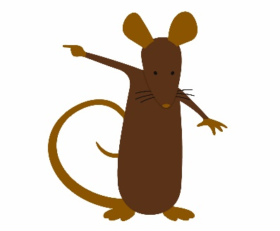

Go through the rest of the WW1 galleries (but there is a mouse to spot – don’t miss it!)

Go into the **60s Gallery**

Go into the shop area and find the chocolate and sweets.

Draw a packet you recognise from shops today.

Look in the sweet shop window.

Draw a packet you *don’t* recognise from shops today.

Go through the **cells**

No chocolate or sugar here!