

**The Victorian Street Fact Pack**

Information for students

Kirkgate is the oldest recreated street in any museum. This Victorian street explores what life was like for people in York from 1870 – 1901. The artefacts you see are original, as are most of the shop fronts. We have used traditional techniques and styles to recreate an authentic Victorian atmosphere.

Listed are the shops found on the street plus a few facts to help you explore Kirkgate. You will find a map at the back of the pack.

**NB** The numbers on the map are simply to allow you to find the correct information for each area; they should not necessarily be followed in numerical order.

**1. Cattle and Barber - Silversmiths**

* Wealthy families would have used silver tableware to show how rich they were.

**Think!**



Why are no prices shown in the window?

**2. Cooke’s Scientific Instruments**

* In 1837, with a loan of £100, Thomas Cooke started business in York as a maker of telescopes.
* The company produced a range of optical instruments including telescopes, observatories, turret clocks and screw cutting equipment.
* Shops like this also sold spectacles and magic lanterns. A magic lantern show can be seen in the Cocoa Temperance Rooms.

**3. Coopers – Saddlers**

* At a time when all local transport was horse drawn, tradesmen who looked after all aspects of horses and carts were very important.

**4. Banks’, Music Sellers**

* The enjoyment of music became more widespread during the Victorian period.
* Wealthier girls were often taught how to play an instrument at an early age. The invention of the upright piano in 1827 meant that even modest-sized houses (who could afford it) had room for a piano
* As recordings of music were not available, buying the music sheets was one way to play the music at home. There were also musical boxes, street piano and the phonograph.

**5. The Little Dust Pan– Furnishing Ironmongers**

* The business was located close to the city centre and the slum districts of Hungate and Walmgate so probably had poor and rich customers
* You can see items in the window that would be part of everyday life such as clothes pegs, brushes and tin baths; however, they also sold desirable items such as fancy candlesticks and glass vases for those that could afford them.

**6. Edward Allen – Taxidermist**

* Although Victorian taxidermist's attitudes to wildlife seem strange by modern standards, remember that many Victorians did not have access to binoculars or cameras.



**Think!**

**Why did they stuff animals and birds?**

**8. Cocoa Temperance Room**

* In the Cocoa Temperance Room you can sit and watch a magic lantern show and look at the scrapbooks about people who lived in York in the time of Kirkgate.
* Temperance means only having alcohol in moderation (or, for some, not having any alcohol at all.
* Pubs were important centres for news and political gatherings. Doctors also prescribed alcohol. A lack of clean drinking water meant that beer was safer.

**Think!**



**How do you think the temperance movement changed people’s lives?**

**9. Rymers’ Undertakers**

* In Victorian times death was common amongst poor districts where living conditions were very bad.
* An undertaker was often a carpenter at the same time. As well as making coffins, they would make and repair items for people’s homes and shops.
* A wealthy Victorian funeral procession would have up to six black horses, with ostrich feather plumes on their heads to pull the hearse.
* At the actual burial, it was more common just for men to attend. It was thought that the experience would be too upsetting for women.
* A lavish spread of food and drink would be served after the funeral.

**Think!**



**Why were so many people dying of diseases rather than old age?**

**10. Horsley, Gunsmith**

* The Horsley gun making business moved to the centre of York in 1856.
* By the end of the 1880s the firm was not only producing crafted firearms but also selling outdoor sporting equipment and running a shooting range. By 1900 the firm was also listed as a cycle agent.

**11. Hardcastle’s Pawnbrokers**

* A pawnbroker is a person who lends money to people in return for their belongings. Their items could be bought back from the pawnbrokers at a later date if they could be afforded.
* Some things could be left in pawn for the whole year and just redeemed at Christmas; Christmas Eve was the busiest day of the year for the pawnbroker.
* Once a family got into habit of regularly pawning items, it was very difficult to escape the practise and it had to continue from week to week.

**Think!**



**What kinds of articles were pawned?**

**What was the pawnbroker’s sign?**

**12. Terry’s – Confectioner**

* The sweet shop would be very busy with many different customers.
* The Victorians believed that sugar was healthy as well as tasty.
* York became very famous for making sweets and chocolate. Brands like Terry’s and Rowntree’s were sold all over the world.

**Think!**



**Why are there no chocolate bars in the window (and it’s not because they would melt!)?**

**13. The Plummer Sisters - Milliners**

* Hats changed with the fashions. Bonnets in the later part of the 19th century were smaller and fussier, with lots of trimming. They were tied under the chin and worn on the back of the head.

**14. Ralph Eden, Tobacconist and Hair Cutter**

* The figure of the Scottish Highlander outside the shop was advertising for snuff.
* There is a smaller highlander attached to the shop itself who would have held matches for passers-by to use to light their pipes.

**15. George Britton, Family & general grocer**

* There are two grocers in Kirkgate – Ambler’s and Britton’s.
* Ambler’s backs onto Rowntree’s snicket and is more basic, Britton’s is more high-class.
* Grocers such as this used bold adverts to tell people about the variety of goods they sold and George Britton, who ran this shop, rarely used the same advert twice.
* Many shops like this one sold new pre-packaged convenience foods such as biscuits in decorated tins, bottled condiments and tinned fruit, meat and fish.

**16. Hansom Cab**

* The hansom cab was designed and patented in 1834 by [Joseph Hansom](http://en.wikipedia.org/wiki/Joseph_Hansom), an [architect](http://en.wikipedia.org/wiki/Architect) from [York](http://en.wikipedia.org/wiki/York).
* Originally called the Hansom safety cab, it was designed to combine speed with safety. They were light enough to be pulled by a single horse (making the journey cheaper than travelling in a larger four-wheel coach) and were agile.
* Although the Hansom cab became an ever-present part of the Victorian street scene - the 'black cab' of its day.  Hansom sold the design for £10,000 to a company which then got into difficulties and couldn't pay him.

**17. Walker’s Horse Repository**

* The horse repository was where you could hire a horse.
* At the beginning of Queen Victoria’s reign, most people travelled by road, either on horseback, in horse-drawn vehicles or on foot.
* Stage coaches were expensive and very uncomfortable. The poorer people could pay for a cheaper ticket which meant they had to sit on the outside of the coach.

**18a. Leak & Thorp– Drapers**

* A draper was originally someone who made woollen cloth but it came to mean any dealer in cloth and textiles. A fancy draper, like Leak and Thorp, sold a wide range of cloth, textiles and accessories
* They sold specialist items to rich people. Gloves were an essential fashion item for a Victorian gentleman or lady. Fans were also an important evening accessory.
* You could buy ‘skirt lifters’ in the draper’s shop. These were a type of metal grip used by Victorian ladies to sweep up their long skirts and stop them from getting dirty.

**Look!**



**What type of items did Leak and Thorp sell?**

**18b. Domestic Slum**

* Houses like this were common in Victorian York.
* There would have been a whole family living in a single room this size.
* Many houses had to share an outside toilet called an ash-pit privy (a loo with a pile of ash instead of water underneath). These were often left uncleared and mess would build up causing a terrible smell and spreading diseases.
* A chamber pot (like the one in this room) was used in poor houses where there was no indoor toilet. It was kept under the bed and then emptied in the morning.

**9a. Prison reception**

* This was the original door to the gatehouse when this building was used as a prison.
* If you look through the hatch, you can see what the outside of the building would have looked like.

**19b. Tallow factory**

* The tallow dip factory made candles from mutton fat. Tallow dip factories had a very strong offensive smell. The candles had the same smell as they burned but tallow candles were cheap to buy and were widely used for lighting throughout the 19th century.



**Think!**

**What do you think it was like working in a tallow factory?**

**20. John Saville & Sons, Pharmaceutical Chemists**

* A pharmaceutical chemist, upon passing exams, would be able to mix, create and sell products of their own making rather than selling pre-made items.
* Many chemists lived above the shop they owned with their families. 16 hour days were not uncommon.

**Think!**



**Why did more people visit the pharmacist than the doctor?**

**21. Rowntrees snicket**

* In 1901, Seebohm Rowntree (son of Joseph Rowntree who owned the chocolate factory) wrote a book on poverty in York
* Seebohm’s report showed that almost a third of York’s population lived in poverty.
* In the slums, houses were often dirty, dark and overcrowded. They would be situated in dark alleyways with very little sunlight and air.
* The diet of those who lived in slums was bread and butter with tea. Sometimes there would be some butcher’s meat, possibly bacon. There was not much variety in meals.

**23. Thomas Ambler Family Grocer & Provision Dealer**

* Grocer’s such as this sold boot buttons and clay pipes as well. It meant that poorer customers became more dependent on one shopkeeper.
* Ambler’s could sell bulk goods at any weight so it was often cheaper for customers than pre-packed
* In the early Victorian period many grocers gained a bad reputation for cheating their customers and adulterating foods, for example putting white lead in flour, ground glass in sugar and red lead in coffee.

**Think!**



**Compare this to the other grocer, Britton’s (no. 15)**

**What would poor Victorians do if they couldn’t afford to buy food?**

**24. Lodgings and second hand clothes shop**

* Many people in Victorian York could not afford to buy new clothes, so they either mended what they had or bought second, third or even fourth hand clothes from shops like these.
* Above the second hand shop is a lodging house; it would have been much cheaper to rent a room in a house like this than to rent a whole house.
* Areas like this often shared a water pump and had poor sanitation



**Think!**

**What evidence can you see that disease was common?**

**25. Allison’s – Cutler**

* Cutlers such as this sold not only cutlery but also ornate sewing scissors, cutthroat razors and cake forks
* You can see knife cases in the window; knife cases stood on the sideboard, so that servants could set out fresh cutlery for each course.

**26. Padded Cell**

* You can look into the padded cell through the thin window in the door, or through a small viewing hole in the passageway to the left.
* Padded cells were used to hold violent criminals to keep both them and the police safe. The padding of horse hair made them soundproof

**27. Epworth’s – Jewellers**

* Epworth’s advertising shows that they sold Ladies and Gents watches and engagement rings amongst many other items; they also gave a present with every wedding ring sold.
* You can see chatelaines in the window; chatelaines are decorative [belt](http://en.wikipedia.org/wiki/Belt_(clothing)) hooks or clasps worn at the waist with a series of [chains](http://en.wikipedia.org/wiki/Link_chain) suspended from them. Each chain is mounted with a useful household item such as scissors, thimble, watch, key, etc

**28. Andersons – Outfitters**

* Anderson’s was a tailor making shirts, suits and hunting gear for wealthy gentlemen.
* Gentlemen could buy items such as collars, to add to shirts.
* This particular shop also specialised in military uniforms and was the official outfitters to East Riding of Yorkshire Imperial Yeomanry.

**Think!**



**Why do you think collars were separate to the shirts?**

**29. Police Station**

* This is a city centre police station with a cell where offenders would be kept overnight before appearing before the Magistrate in the morning.
* The police cell is in fact a prison cell (from when the Castle Museum buildings were used as York’s Prison) and the iron bed dates from the early 19th century. The Iron Gate which leads into the inner cell is also original, although the bars on either side are wooden.



**Think!**

**What crimes would mean you spent a night in a police cell?**

**30. Kirkgate Board School**

* The Kirkgate Board School is a recreated schoolroom from the 1890s. Many children in early Victorian Britain never went to school although some went to Sunday schools run by the church.
* Many teachers were strict. This was partly because in schools before 1850, one teacher might be in charge of a class of over 100 pupils.
* Lessons concentrated on ‘the three R’s’: **r**eading, w**r**iting and a**r**ithmetic.



**Think!**

**How did the students learn maths?**

**How were they punished?**

**31. Kendrick’s Toy Dealers & Fancy Repository**

* This shop is for wealthier children; poorer children would have had toys made for them by friends and family or have bought cheap toys such as basic skipping ropes and spinning tops for a penny from a street trader.
* Parents saw toys as educational. Girls were taught domestic skills with toys including irons and mangles whilst boys were given scientific toys.
* A Noah’s Ark was a popular toy to be played with on a Sunday as it was religious.

**Think!**



**Which toys would be played with by boys and which by girls?**

**Were the toys in the shop for rich or poor children? Reasons?**

**32. Wehrly’s – Clockmaker**

* Wristwatches did not become popular until the 1920s, so most gentlemen carried a pocket watch on a chain attached to their waistcoat.
* The clockmaker’s workshop can be seen to the left of the shop front.

**33. Greenwood’s Antique Shop**

* Greenwoods were a cabinet maker who also sold works of art, ancient furniture, old china, bronzes and curiosities.



**Look!**

**What types of goods were sold?**

**34. Sessions – Printer, Stationer & Bookseller**

* During the final 30 years of the 1800s there are over one hundred addresses in York that housed a bookseller, stationer or printer at some point.



**Think!**

**What does this suggest about education?**

**35. J Kidd Boot maker**

* There were very many boot and shoe shops in York in the late 1800s; in 1896 there were 137 listed in the Trade Directories. Boot makers like J Kidd working on the streets where people lived were as important as the corner grocer.



**Think!**

**Why were Boot makers important?**

**Why did people have their shoes and boots mended rather than buying a new pair?**

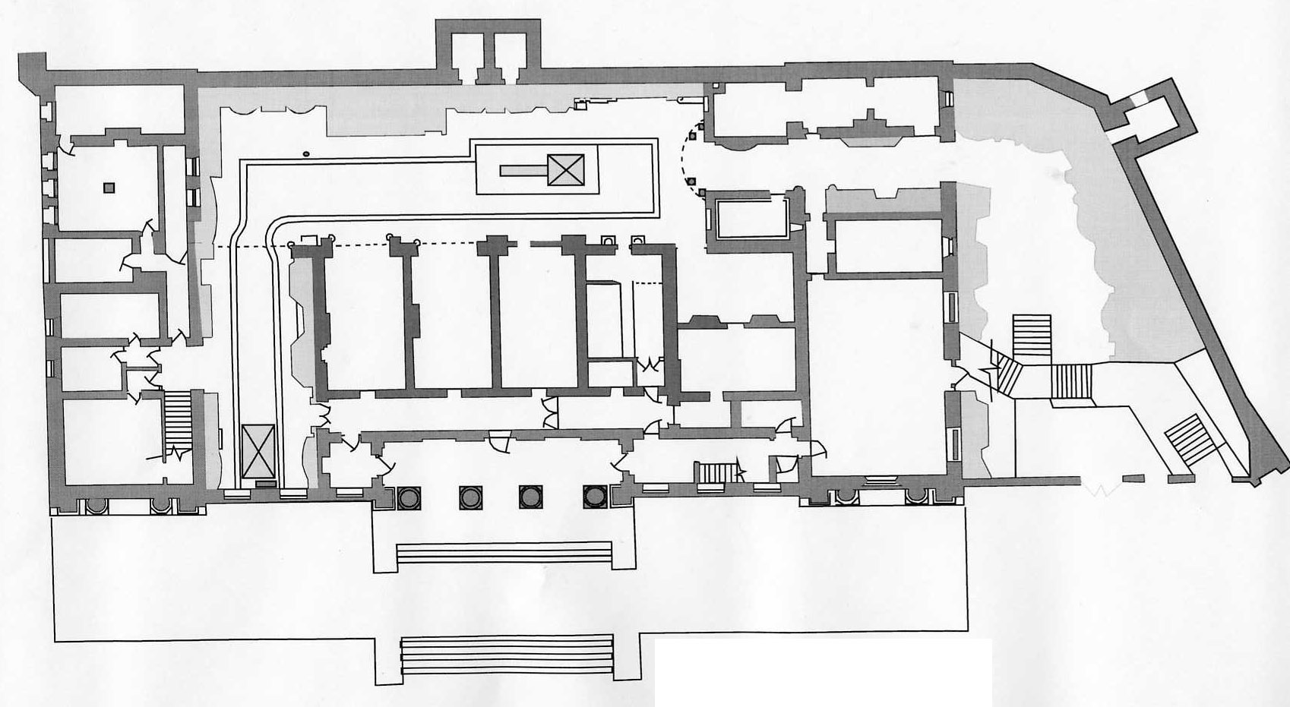

1

2

4

5

6

3

9

10

11

120

1711

18a

19a

16

13

21

20

14

15

23

24

29

30

26

32

31

28

27

25

34

35

33

8

7

22

18b

36

19b

|  |  |  |  |  |  |  |
| --- | --- | --- | --- | --- | --- | --- |
| 1 | | Cattle and Barber Silversmith | 13 | E & A Plummer Milliners | 24 | Lodging house + second hand clothes shop |
| 2 | | T Cookes Scientific Instruments | 14 | Tobacconist | 25 | Allison Cutlers |
| 3 | | Cooper’s Saddlers | 15 | Britton’s High end grocer | 26 | Padded Cell |
| 4 | | Banks’ Music shop | 16 | Hansom Cab | 27 | Epworth’s Jewellers |
| 5 | | The Little Dust Pan Furnishing Warehouse + Ironmongers | 17 | Horse Repository | 28 | Anderson’s Military Outfitters |
| 18a | Leak and Thorp drapers |
| 6 | E Allen Taxidermist | 18b | Domestic interior | 29 | Police station |
| 7 | Toilets | 19a | Prison reception | 30 | School Room |
| 8 | Cocoa Room | 19b | Tallow factory | 31 | Kendrick’s Toy Shop + Fancy Repository |
| 9 | Rymer’s undertakers | 20 | John Saville Pharmaceutical chemist | 32 | Wehrly & Co Clockmakers |
| 10 | Horsley’s Gunsmith | 21 | Rowntree snicket | 33 | Greenwoods Antiques Shop |
| 11 | Henry Hardcastle Pawnbroker | 22 | Back entrance to grocer’s | 34 | Sessions stationers |
| 12 | Barton’s sweet shop | 23 | Amblers Family grocers | 35 | J Kidd’s boot makers |