

Early Years Nursery Rhymes Trail

This Gallery trail explores:
The Period Rooms
Kirkgate, the Victorian Street

This trail is designed for an adult to use with a small group of children. Children should speak their answers and there is no need to write any answers down unless you choose to do so for your own assessment purposes.

Links to early learning goals:
Listening and attention: Children listen attentively in a range of situations and respond to what they hear with relevant comments, questions or actions.
Understanding: Children answer ‘how’ and ‘why’ questions in response to stories or events.
Self-confidence and self-awareness: Children are confident to try new activities, and to speak in a familiar group.

Find the Victorian Parlour


Sing ‘Sing a Song of Sixpence’
Sing a song of sixpence,
A pocket full of rye.
Four and twenty blackbirds,
Baked in a pie.

When the pie was opened,
The birds began to sing;
Wasn't that a dainty dish,
To set before the king?

The king was in his counting house,
Counting out his money;
The queen was in the parlour,
Eating bread and honey.

The maid was in the garden,
Hanging out the clothes,
When down came a blackbird
And pecked off her nose.

Could the queen be in this parlour eating bread and honey?
Ask
Why not?
(Answer: No, because there is no honey!)

Find the Moorland Cottage

Sing ‘Hey Diddle Diddle’
Hey diddle diddle,
The cat and the fiddle,
The cow jumped over the moon.
The little dog laughed to see such fun,
And the dish ran away with the spoon.
Ask
Which animal from the rhyme is not here?
(Answer: the cat)
Can you spot a dish and some spoons?
(Answer: the dish is hanging on the left hand wall and a rack of spoons is hanging on the right)

Find the Georgian Room
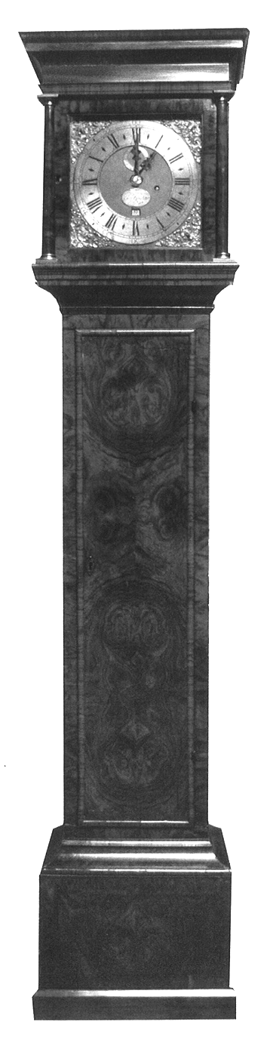
Sing ‘Hickory Dickory Dock’
Hickory, dickory, dock,
The mouse ran up the clock.
The clock struck one,
The mouse ran down,
Hickory, dickory, dock

Ask
What shapes can you spot on the long case clock?
(Answer: they might be able to find a circle on the clock face and squares and rectangles on the case)
Find the 17th Century Dining Room

Sing ‘Rock a bye baby’
Rock-a-bye baby, in the treetop
When the wind blows, the cradle will rock
When the bough breaks, the cradle will fall
And down will come baby, cradle and all

What is the cot made from?
Ask
(Answer: wood)
How could you make it comfy for a baby?
(Possible answer: you could put something soft inside like a blanket)

Look in the Toy Stories gallery

Can you spot any nursery rhymes or storybook characters painted here?
(Answer: look at the large mural at the far end of the gallery – you can spot the Grand Old Duke of York, the Three Bears, Jack and Jill and possibly many more!)

Find the 1950s Front Room

Sing ‘Pussy cat, pussy cat’
Pussy cat, pussy cat, where have you been?
I've been to London to look at the Queen.
Pussy cat, pussy cat, what did you do there?
I frightened a little mouse, under the chair.

Can you spot a good way for a Queen to travel?
Ask
(Answer: the gold Coronation coach and horses)
How many horses has the coach got? Has every horse got a rider?
(Answer: 8 and no)
Head into the Shaping the Body gallery

Sing ‘Little Boy Blue’
Little boy blue,
Come blow your horn,
The sheep's in the meadow,
The cow's in the corn.
But where is the boy
Who looks after the sheep?
He's under a haystack,
Fast asleep.

Can you spot a blue boy’s dress?
Ask
(Answer: in the case to the left of the stairs – boys used to wear dresses until they were about 5)

Head into the Hearth gallery

Sing ‘Polly put the kettle on’
Polly put the kettle on,
Polly put the kettle on,
Polly put the kettle on,
We'll all have tea.
Suky take it off again,
Suky take it off again,
Suky take it off again,
They've all gone away.

Can you spot three kettles?
Ask
(Answer: in the 1940s kitchen, the 1980s kitchen and on the hearth on the right hand side)

Head down the stairs

Sing ‘The Grand Old Duke of York’
Oh, the grand old Duke of York,
He had ten thousand men,
He marched them up to the top of the hill
And he marched them down again.
And when they were up they were up,
And when they were down they were down,
And when they were only half way up
They were neither up nor down.

What colour is the old soldier’s uniform?
Ask
(Answer: red)

Head onto Kirkgate, the Victorian Street

There are many things to spot here linked to Nursery Rhymes:
Large fish in the Taxidermist’s shop for ‘1, 2, 3, 4, 5’
Cotton reels in the Milliner’s shop for ‘Wind the bobbin up’
Pipes in the Tobacconist’s shop for ‘Old King Cole’
Horse pulling the Hansom Cab for ‘Horsey horsey’
Tubs outside Ambler’s Grocer for ‘Rub a dub dub’
A star brooch in Epworth’s jeweller’s for ‘Twinkle twinkle’
Shoes in Kidd’s Bootmaker’s for ‘Cobbler cobbler mend my shoe’

