

Early Years Numeracy Trail on Kirkgate

This Gallery trail explores
Kirkgate, the Victorian Street

This trail is designed for an adult to use with a small group of children. Children should speak their answers and there is no need to write any answers down unless you choose to do so for your own assessment purposes.

Links to maths development early learning goals:

Numbers: Children count reliably with numbers from one to 20. Using quantities and objects, they count on or back to find the answer. They solve problems, including doubling, halving and sharing.

Shape, space and measures: Children use everyday language to talk about size and position to compare quantities and objects and to solve problems. They explore characteristics of everyday objects and shapes and use mathematical language to describe them.
Turn right at the bottom of the stairs that lead onto Kirkgate from the other galleries

Find T Cookes Scientific Instrument shop
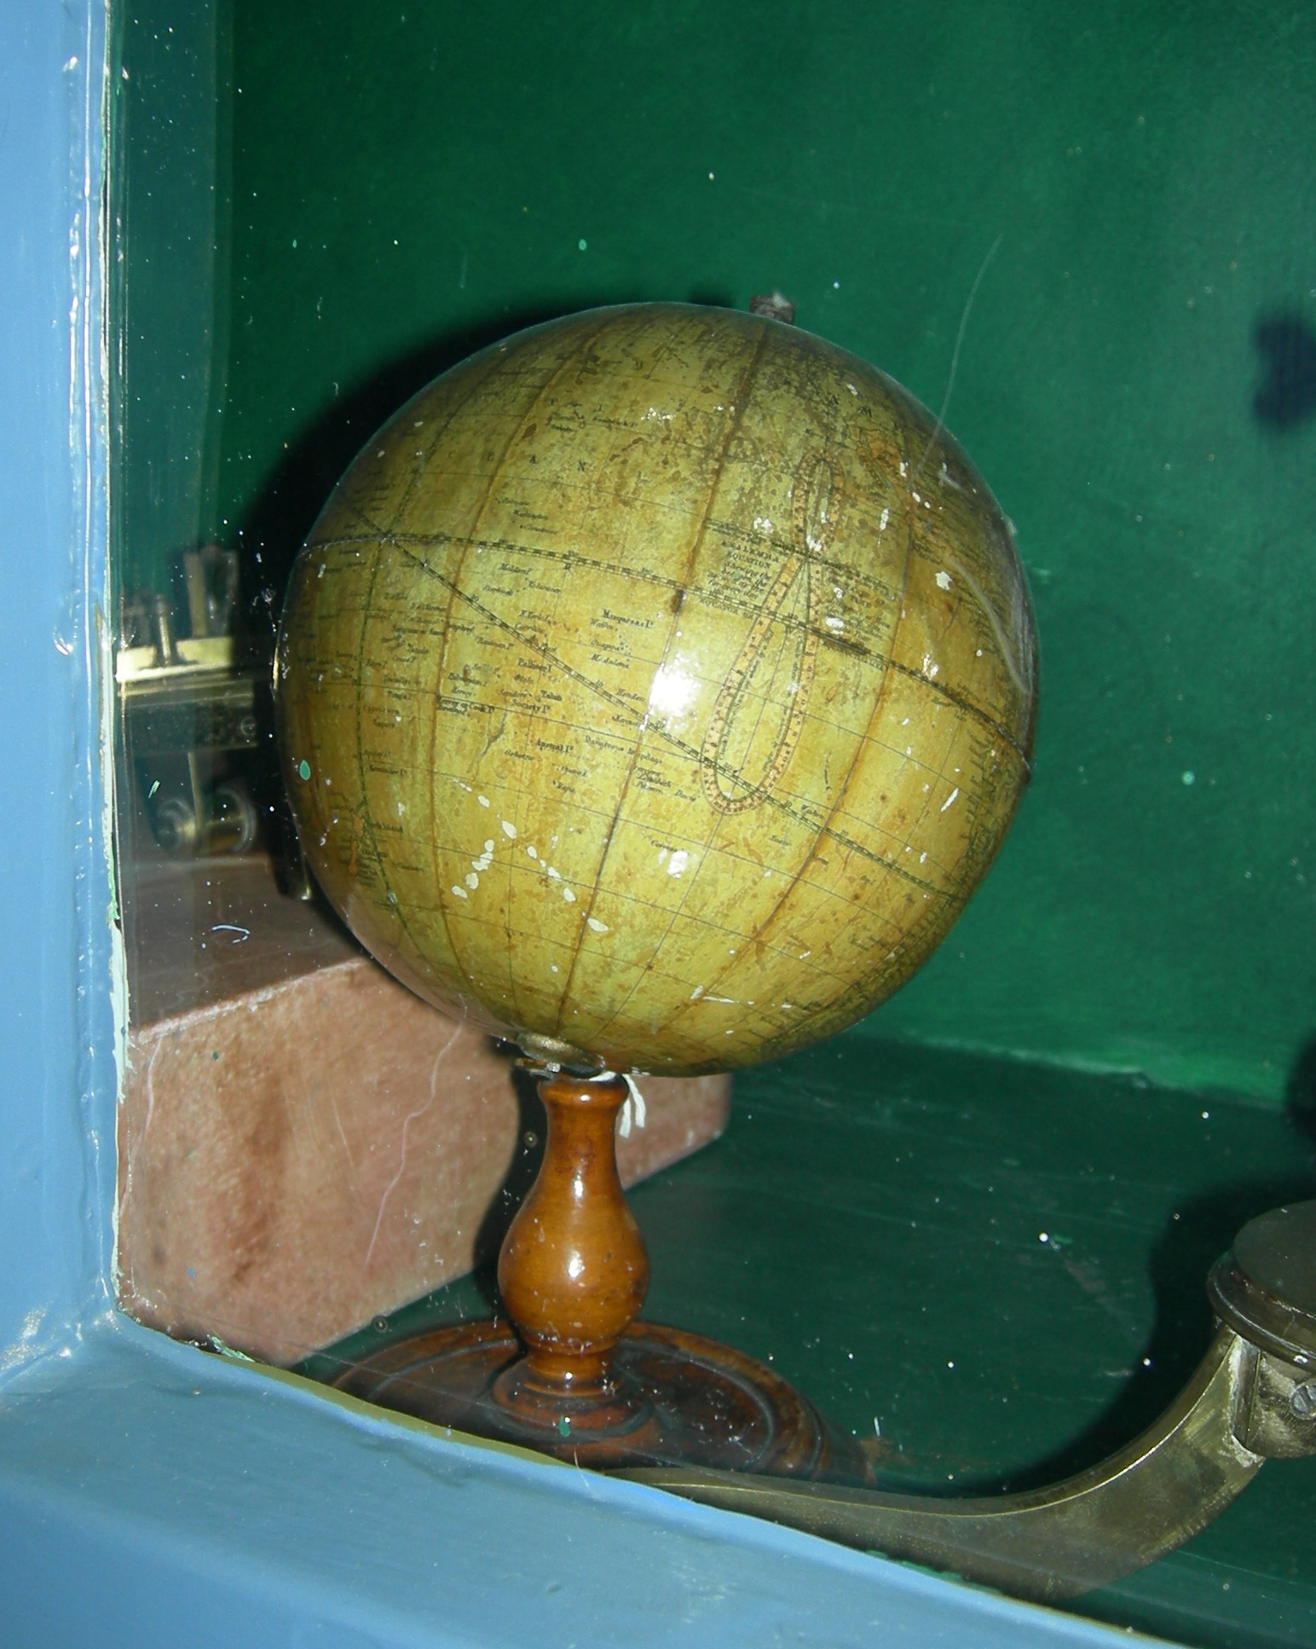

Can you find something that is a sphere?

Find Banks’ Music shop

Look on the top two shelves only. How many instruments do you blow?

Find Horsley’s Gunsmith

What is the biggest thing you can find in this shop window?

What do you think is the smallest?

Find the Horse Repository (where the horse bridles are hanging)
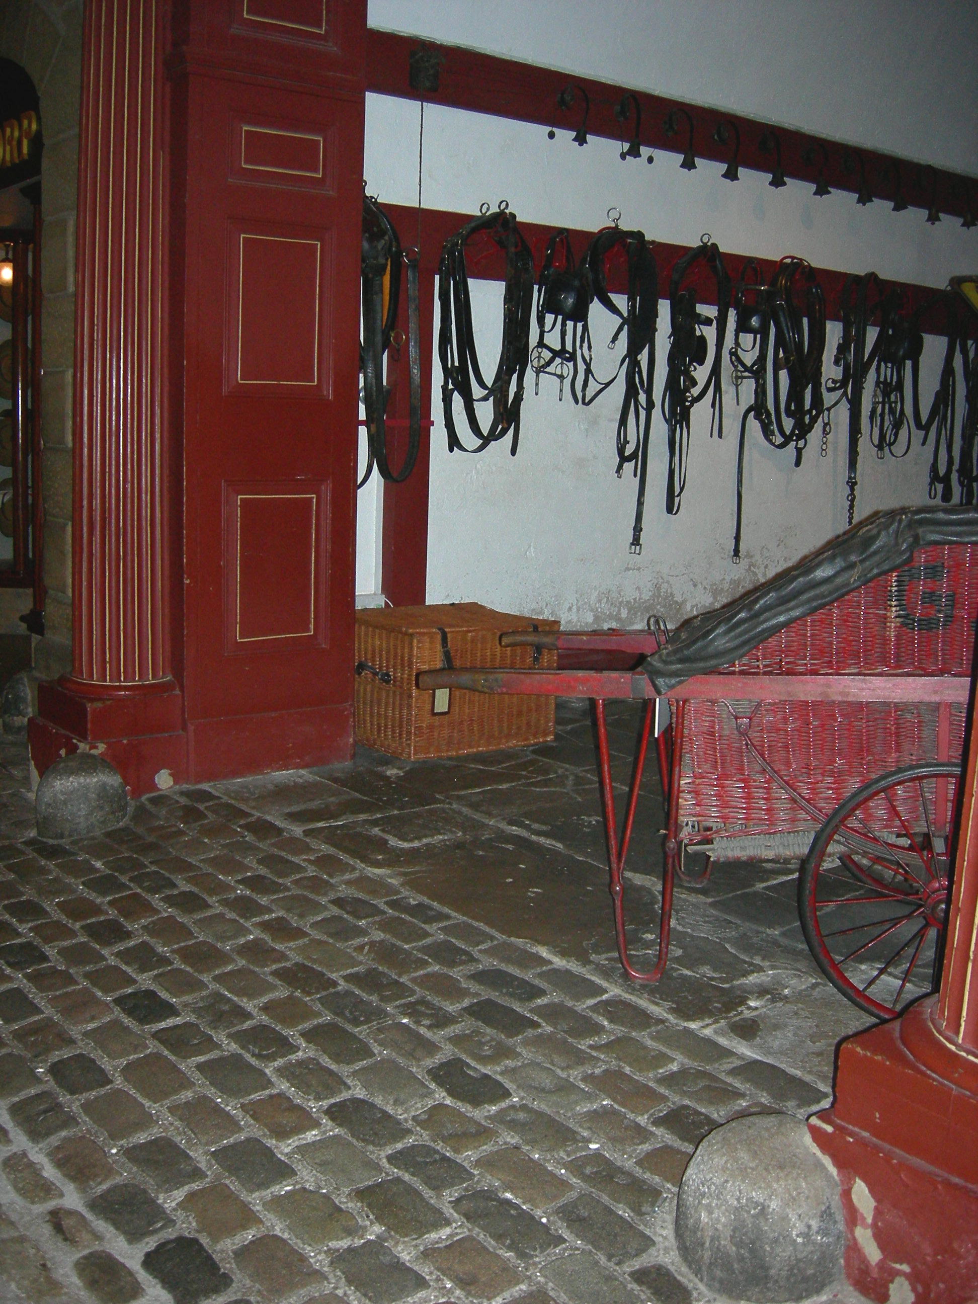
How can you measure the space between the two large stones in the doorway? (Hint: use yourselves)

Have a go and see how big it is.

Find Leak and Thorp drapers

How many coat buttons does the blue jacket in the window have?

Find the Hansom Cab

How many squares can you find? Look carefully!

Find John Saville Pharmaceutical chemist

What shape is the window above the door?

Find the large green and blue jars. How many are there of each colour?
If one blue one got broken, how many would there be?
Find Ambler’s grocers shop

What is on top of the shop? (There is more than one thing to spot)

Find Kendrick’s Toy Shop

Find the wooden mallets and balls. How many mallets are there? How many balls? Is there enough for one each?

Find Session’s printers and book shop

What animal can you see next to the picture of the lion?

And finally…

What shape are the adverts at the very end of Kirkgate?

