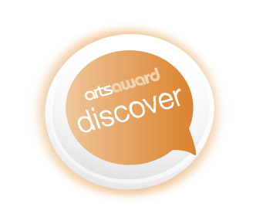
YMT Arts Award Discover Workshops
Arts Award Discover is an introductory award aimed at 5 to 9 year olds (although any child can take part.)
York Museums Trust, Explore York Libraries, York Minster and York Theatre Royal are offering children the opportunity to gain Arts Award Discover through taking part in any three creative activities and finding out about artists and crafts people.
Collect a stamp or sticker at each activity then come to the York Theatre Royal on Sunday 17 September between 10.00 am and 3.00 pm to complete your award by telling us what you did. After talking to you we will apply for your Arts Award certificate which will be posted to your home.
There is a £3.50 charge payable on the day for certificates.
Please note: ALL sessions are for accompanied children.
You can also attend these sessions if you do not want to take the
Arts Award.

Date | Times | Venue | Activity | cost
Wed 27 Jul | drop-in  10am - 3pm | York Minster | Sculpt your own bird shaped ornament | £2.50*
Fri 29 Jul | drop-in  10am – 12noon | Tang Hall Explore Library | Goldilocks on Trial How would you feel if someone broke into your house? Come and join Mud Pie Arts and be part of the jury to decide the fate of Goldilocks.  Be a Roald Dahl Illustrator Draw your favourite character. | FREE
Mon 1 - Wed 31 Aug | drop-in  11am - 1pm & 2pm - 4pm | York Art Gallery | Fancy Dress Portraits Dress up as your favourite character then look in a mirror and draw your portrait.  Every day - drop-in. | FREE*
Sat 1 - Mon 31 Aug | drop-in  11am - 1pm & 2pm - 4pm | York Castle Museum | Picture Postcards Design and make your own postcard inspired by First World War postcards in our exhibition 1914 When the World Changed Forever.  Every day. just drop-in. | FREE*
Mon 1 – Sun 7 Aug | drop-in  11am - 1pm & 2pm - 4pm | Yorkshire Museum | Marvellous Model Making: Soap Sculptures  Be inspired by our Roman jet pendants. Carve your own portrait into a mini bar of soap to take away with you. Then you can wear it or wash with it! | FREE*
Tue 2 Aug | drop-in  2pm - 4pm | Acomb Explore Library | Goldilocks on Trial How would you feel if someone broke into your house? Come and join Mud Pie Arts and be part of the jury to decide the fate of Goldilocks.  Be a Roald Dahl Illustrator Draw your favourite character. | FREE
Wed 3 Aug | drop-in  10am - 3pm | York Minster | Create a sparkling sun catcher | £2.50*
Wed 3 Aug | following the matinee | York Theatre Royal | Sherlock Holmes; The Hound of the Baskervilles post show discussion with the director, Damian Cruden **Takes place in the auditorium, for anyone with a ticket to the production who is doing their arts award | FREE**
Mon 8 – Sun 14 Aug | 11am – 1pm & 2pm – 4pm | Yorkshire Museum | Marvellous Model Making: Amazing Maize Modelling  Have fun with this a-maizing material as you build a mini human sculpture, piece by piece | FREE*
Wed 10 Aug | drop-in  10am - 3pm | York Minster | Make your own decorative clay tile. | £2.50*
Thu 11 Aug | 11am - 12noon | York Theatre Royal | Sherlock Holmes: One of Our Hounds is Missing Workshop | £5.00**  aged 8+
Mon 15 – Sun 21 Aug | drop-in  11am - 1pm & 2pm - 4pm | Yorkshire Museum | Marvellous Model Making: Junk Modelling  Re-use and recycle a variety of materials to create a sculpture inspired by our Roman collections. | FREE*
Wed 17 Aug | drop-in  10am - 3pm | York Minster | Design and make a metalwork-style badge. | £2.50*
Mon 22 – Sun 28 Aug | drop-in  11am - 1pm & 2pm - 4pm | Yorkshire Museum | Marvellous Model Making: Clay Sculptures  Use clay to make a sculpture of a head pot or a Roman god.. | FREE*
Wed 24 Aug | drop-in  10am - 3pm | York Minster | Create your own family banner in fabric. | £2.50*
Wed 24 Aug | drop-in  2pm - 4pm | York Explore Library | Goldilocks on Trial How would you feel if someone broke into your house? Come and join Mud Pie Arts and be part of the jury to decide the fate of Goldilocks.  Be a Roald Dahl Illustrator Draw your favourite character. | FREE
Wed 31 Aug | drop-in  10am - 3pm | York Minster | Try your hand at weaving your own keepsake. | £2.50*
Fri 2 Sep | 4:30pm – 6pm | York Theatre Royal | The Witches drama workshop  With the Assistant Director, Jenna Drury.  For ages 8-11s. | £6.00
Sat 17 Sep | drop-in  10:00 pm - 3:00pm | York Theatre Royal | The BIG Share Did you complete this year’s Summer Reading Challenge and take part in three or more Arts Award Discover Activities? Come along and share what you did with one of our assessors to complete your award. | £3.50  to cover certificate + postage

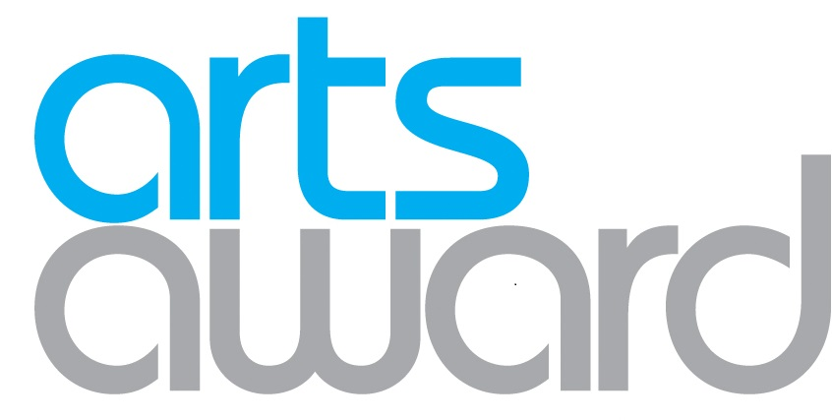
*normal admission costs apply - see venue websites for details.

** York Theatre Royal events must be booked through York Theatre Royal Box Office
on 01904 623568.

