

KS1 Homes Gallery Trail

This Gallery trail explores the following galleries:

In the First section of the Museum:

Period Rooms
The 1950s Front Room
1940s and 1980s kitchens

National Curriculum links:
History:
They should ask and answer questions, choosing and using parts of stories and other sources to show that they know and understand key features of events. They should understand some of the ways in which we find out about the past and identify different ways in which it is represented.
Pupils should be taught about changes within living memory. Where appropriate, these should be used to reveal aspects of change in national life

My Name………………………………………………………………

Homes Gallery Trail

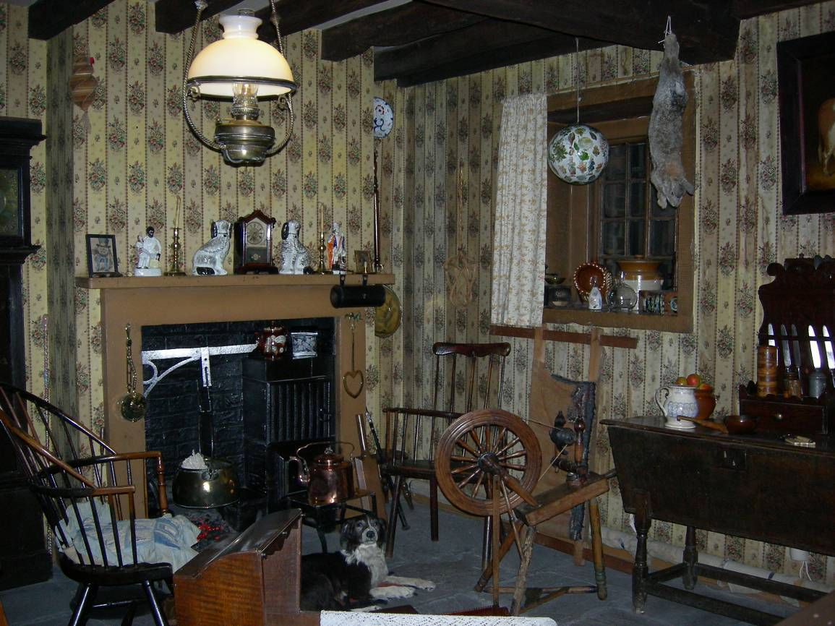
Look in the Moorland Cottage.
1
2
3
3
Draw and label what is missing in the picture.
3
1
2
3
2
1
1
2
2
2

Look in the Victorian Parlour.

What two hobbies could you have had if you lived here?
………………………………………………………………………………
………………………………………………………………………………

Look in the Georgian Room.

Look at the items on the window ledge.

What do you think the person who lived here liked to do?
……………………………………………………………………………………………………………………………………………………………………………………
Look in the 1700s Dining Room.
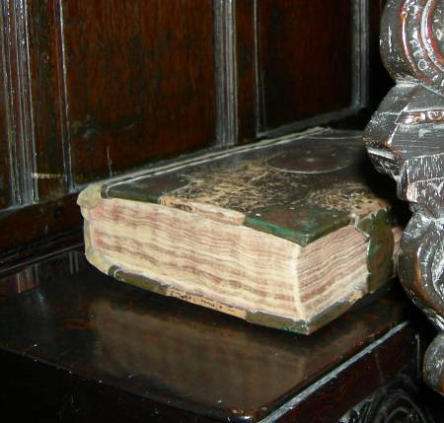
The book on the left hand side was very important to the people who lived here.

What do you think it is?
………………………………………………………
Look in the 1950s Front Room.
Spot 3 objects which use electricity. Use the word bank to help you.

1
Word Bank
Lamp
Playstation

Washing Machine
Toy train
CD player

Fire Radio
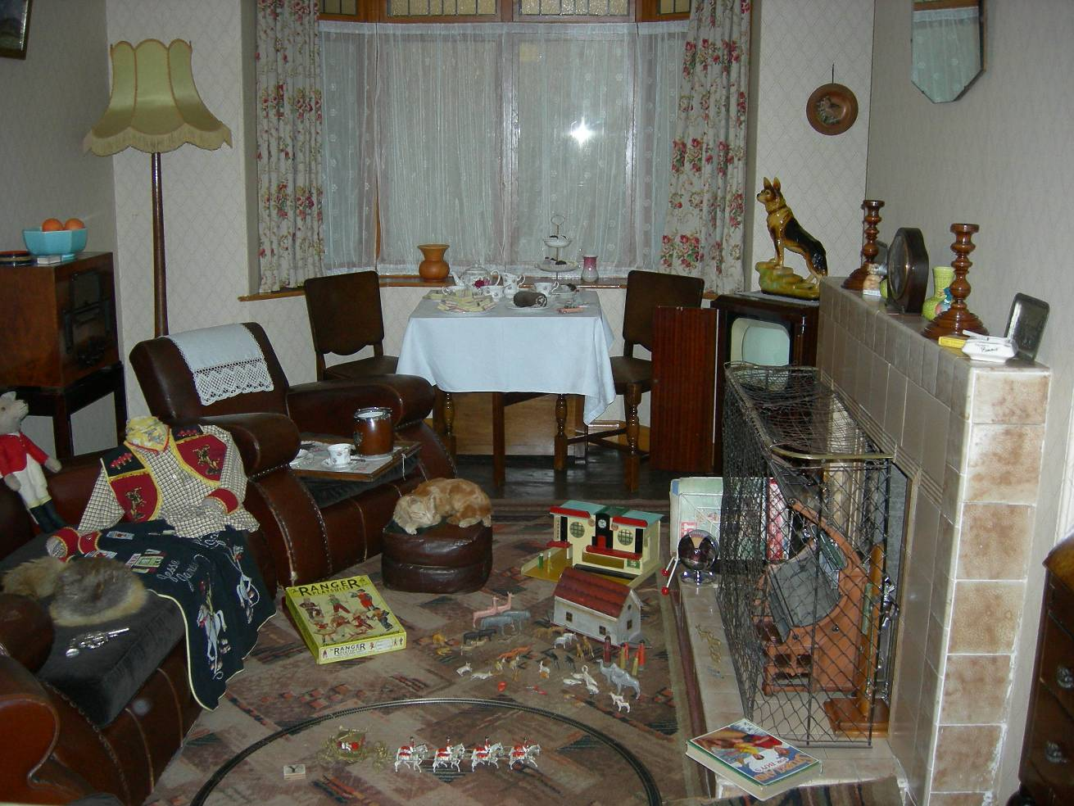
2

1.

2.

3.

Name two things you have at home that use electricity that you would not have had if you lived in the 1950s.

- ………………………………………………………………………………
- ………………………………………………………………………………
3

Look at the kitchens

Find a cooker which uses an open fire to cook. Draw a picture.

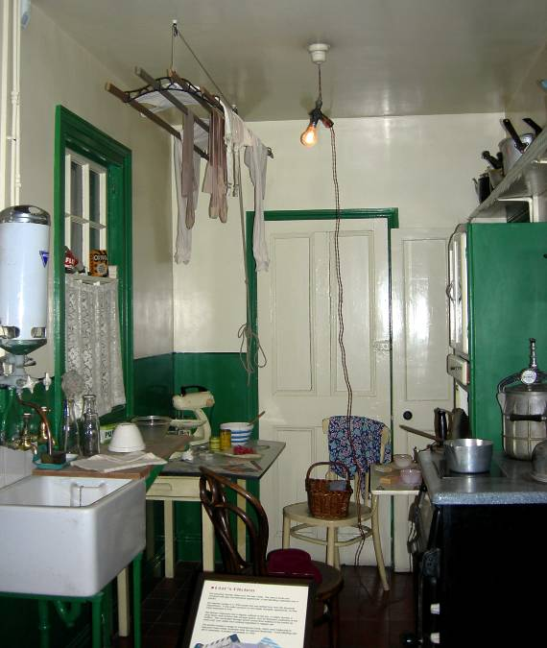
This is a 1940s Kitchen
This is a 1980s Kitchen

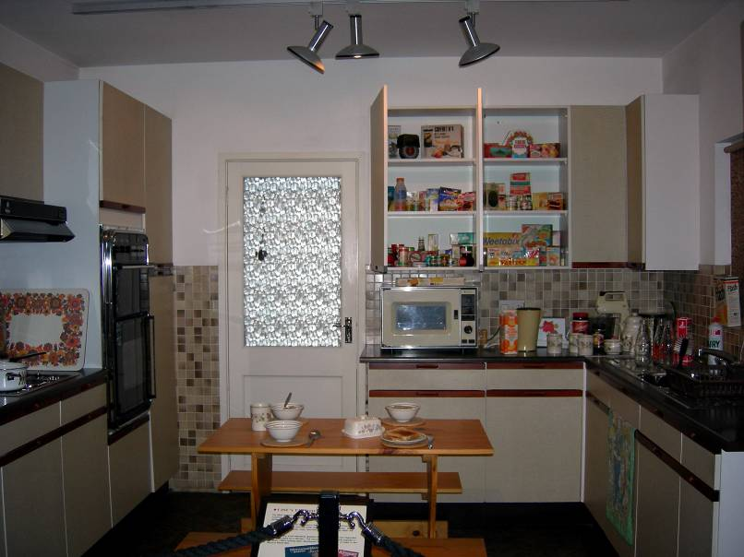
Match the objects to the right kitchen


