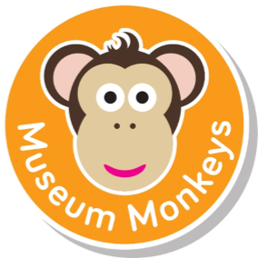

Museum Monkeys events for under 5s
Only £4 per session, museum admission applies.
Sessions run term time only.

Museum Baby (under two years old) Fridays, 10am – 11am
Special baby sessions linked to exhibitions, including songs and sensory activities for babies and their carers. Sessions are a mixture of free flow and adult led activities which all relate to the early years Curriculum. A perfect introduction to museums!
Museum Baby
Art Gallery
Wood
4th November
Feel the textured wood in the sensory area and play with the traditional wooden toys.
Cloth
11th November
Discover different texture cloth, play with rag dolls and make a den with the materials.
Fur & Feathers
18th November
Play in the fur and feather investigation area and listen to the bird sounds.
Clay
25th November
Feel the different textures of clay and paint with clay slip.
Paper
2nd December
Play in the shredded paper area and investigate how to crinkle, rip and roll paper.

Early Years Explorers (two – five years old) Thursdays, 10am – 11am
Activities for children aged two to five years old which include songs, stories, games and craft activities. Sessions are based on familiar preschool play areas, which are enhanced to help children learn about the museum’ collections and exhibitions through play. Sessions are a mixture of free flow and adult led activities which all relate to the Early Years curriculum.

Early Years Explorers
Yorkshire Museum
Dinosaurs
3rd November
Play with the dinosaur toys, make a plaster cast fossil and look at fossils from the collection.
Birds
10th November
Listen to the bird sounds, look at taxidermy birds and decorate a bird house.
Space
17th November
Play with the inflatable planets and space man puppet. Look at the meteorite and make a coloured clay planet.
Minibeasts
24th November
Find the minibeasts in the sand, look at minibeasts from the collection and make a minibeast collage.
Colours in History
1st December
Investigate colours in history, use coloured cellophane to make a stained glass window and make medieval illuminated letters.

Museum Monkeys Christmas Specials at York Castle Museum
10am – 11am and 11.30am - 12.30pm
Early Years Explorers Thursday 15th December
Be an elf and help Santa to pack the toys, go down the chimney like Santa, and find the stars in the Reindeer food.
Museum Babies: Friday 16th December
Be an elf and help Santa to pack the toys, go down the chimney like Santa, and find the stars in the reindeer food.

HOW TO BOOK
Please book sessions using our Eventbrite page, follow this link: http://tinyurl.com/oh46tnj
Please Note: If you are unable to attend please cancel your booking to allow others to participate.

